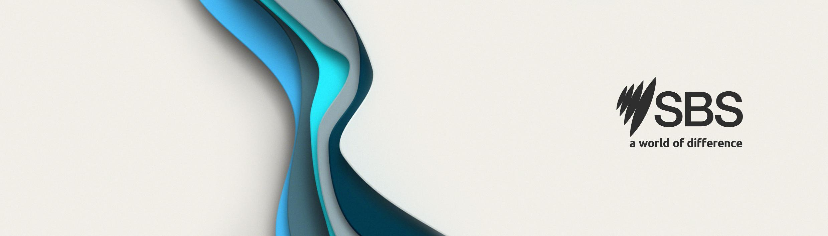
Job
Description

Senior Software Engineer – Full Stack
SBS – Sydney Based

Reports to: Program Lead – Digital Transformations

SBS Values, Vision and Purpose
The Software Engineer is responsible for undertaking their work in a way that reflects SBS’s Charter, Vision and Values and complies with relevant SBS policies, procedures and practices. At SBS, we expect you to be audience obsessed, be bold and brave, embrace difference, participate fully and ensure that we look out for one another. We are all working together to fulfil SBS’s purpose and create a more cohesive society.

Division Purpose – Streaming and Digital Products
SBS SDP can be thought of as the 'engine room' of SBS. Our primary role is to enable and support the production, distribution, and transmission of content across television, radio, and online platforms. Our teams achieve this by working collaboratively to design innovative solutions and deliver end-to-end services for our business stakeholders.

Currently several SDP staff are assigned to an AI Incubator Program, a program which is prototyping AI tools for both staff productivity and audience facing features.

Division Purpose – Streaming and Digital Products
Streaming and Digital Products department is responsible for SBS’ core digital platforms and services. SDP builds, maintains, and supports key products, including: sbs.com.au; SBS News, Sport, Languages, NITV, Audio, and Mobile Apps. This specific role is part of a specialised team who are prototyping exciting new capabilities using the latest AI techniques, more details will be supplied as you progress through interviews.

Role Purpose
SBS seeks an experienced Senior Software Engineer to join the team that develops SBS’ digital network
(www.sbs.com.au), specifically for the AI Incubation Program.

You will be joining a progressive organisation with a team of backend, front-end and mobile apps developers as well as designers and UX experts. You will contribute as a highly autonomous Software Engineer with good coding skills in React.js and Typescript with a strong focus on Frontend development coupled backends utilising SaaS datastores and workflows.

This is a hybrid job that will be based in Sydney, Australia. It is initially on a fixed term full time basis until end June 2025. If you want you can mostly work from home as all our dev teams do, however you will be required to come into the Sydney office for in person team meetings/events and to interact with our internal users, one day per week on average.

Main Responsibilities
Key Outcomes
- Develop new frontend code for “web apps” using React.js
- Develop Backend code in node.js/typescript and/or GoLang (your choice) in a serverless AWS environment.
- Build testable, reusable code and libraries for future use across all SBS digital platforms
- Write unit tests to achieve maximum meaningful coverage
- Write meaningful supporting documentation to minimise single points of failure
- Help provide ad-hoc support to users of the systems we develop
- Refactor existing code to eliminate technical debt
- Effective use of APIs and some SaaS data storage such as DynamoDB and S3

Actions and Processes
- Optimize application for maximum performance, scalability, and accessibility
- Collaborate with other team members and stakeholders to achieve the best outcomes

Essential Skills
- Proven work experience as a Software Engineer in an Agile team environment
- Good knowledge of React.js and Typescript
- Good knowledge of modern web frameworks and libraries.
- Good understanding of build tools/pipelines including Git, Yarn/NPM & Node.js

Desirable Skills
- Understanding of CI/CD engineering practices and DevOps processes
- Understanding of performance optimisation
- A keen interest in AI, though existing expertise is not required
- Python knowledge or desire to learn will be a bonus, particularly for rapid prototyping of AI.
Personal Skills
- Ability to evaluate priorities and communicate within the team
- Organised and self-sufficient
- A keen ability to upskill and transfer knowledge as appropriate

