

POSITION DESCRIPTION

Position Title: | Environmental Health Technical Officer | Directorate: | Infrastructure & Development
Position Number: | 100143 | Department: | Development
Employment Status: | Part-Time | Section: | Environmental Health
Employment Type: | Permanent | Location: | Chambers
Classification: | Schedule A, Salary Point 6 (+1) | Location: | Chambers
Reports to: | Senior Environmental Health Officer

PRIMARY PURPOSE:

The primary function of this role is to assist with Environmental Health services, including the provision of advice and making recommendations within the scope and relevant authority of the position.

ORGANISATIONAL REPORTING RELATIONSHIPS:

- Internal:
- The Technical Officer reports to the Senior Environmental Health Services for all operational and management matters.
- The role is a key contributor to the Development Team and will liaise with employees of Council.

- External:
- The role will liaise with external stakeholders such as members of the general public, ratepayers, residents, property owners and developers, food and industry operators, Government and statutory authorities, other local government organisations, business sector and peak bodies, visitors and contractors to the City of Glenorchy.

OUR VALUES:
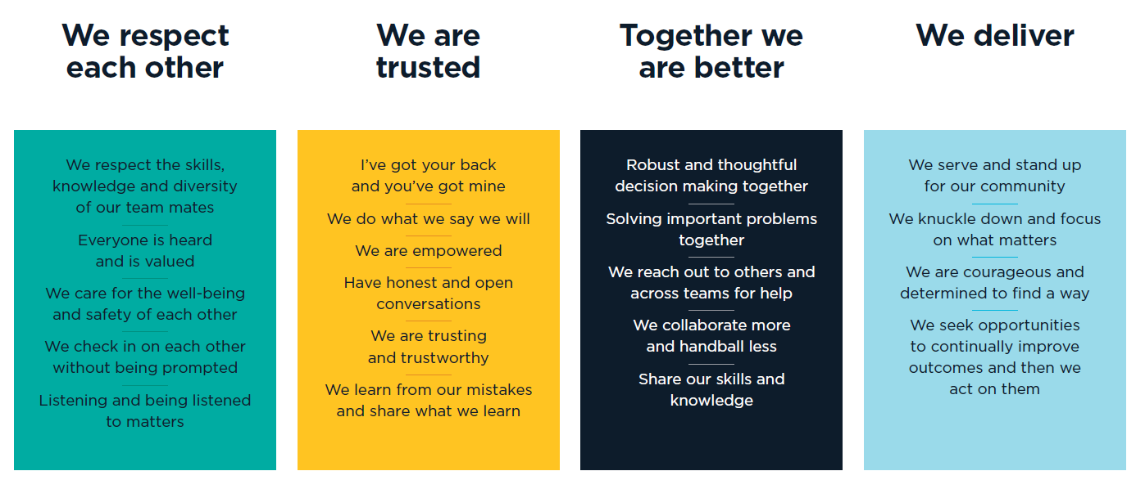


OUR CULTURE:
We foster and model a culture where:
- We RESPECT others and their viewpoints as being as important as our own.
- We trust and are TRUSTED by each other.
- We know that by working TOGETHER we achieve better outcomes.
- We take personal responsibility, and together we DELIVER for our community.
This is OUR WAY to achieve results through our people and teams to make Glenorchy a better place every day.

KEY RESPONSIBILITES:

RESPONSIBLITIES/TASKS | DUTIES
Environmental Health | - Recreational Water Quality  - Undertake recreational water sampling at beaches, creeks, pools and other environmental sites as required and recording relevant observations.  - Assist in the review of water sampling practices and procedures.  - Maintain recreational water sampling results.  - Customer Requests  - Investigate requests relating to the Environmental Management and Pollution Control Act 1994, Local Government Act 1993, Litter Act 2007, and Council By-laws.  - Apply procedural fairness, determine investigation outcomes, and make recommendations to the Senior Environmental Health Officer.  - Maintain accurate and comprehensive investigation records.  - Provide education, recommendations, and advice to members of the public on matters relating to Environmental Health.  - Immunisation Program  - Assist with Council’s immunisation programs as required.
Other Duties | - Work efficiently, autonomously and as part of a team and use own discretion to make sound decisions within delegated authority.  - Be adaptable and flexible and perform at a high level in an environment subject to pressure, stress and changing work priorities.  - Identifying and making recommendations to promote cross-department linkages within Council to assist in the effective coordination of environment and public health issues.  - Assisting Environmental Health Officers and other section staff in the performance and completion of other roles and responsibilities of the Section in accordance with any reasonable direction and within the level of responsibility for the position.  - Follow procedures, instructions and complete tasks with a high degree of accuracy and efficiency.  - To be responsible for the planning and coordination of own work relevant to the roles and responsibilities of the Section and in accordance with any Council policies and procedures.  - To ensure all correspondence and enforcement actions are actioned in compliance within performance requirements.
Customer Service | - Promote the positive image of Council as a whole  - Ensure that a high standard of customer service is maintained to both internal and external customers  - Engage, listen to and act where appropriate on feedback from our customers  - Implement, evaluate and continuously improve quality systems and processes for the section
General | - Assist in the achievement of agreed outcomes consistent with department business plans and budgets  - Perform any other duties as directed
Organisational Responsibilities | - Support and adhere to Council’s policies and procedures, code of conduct and relevant acts  - The incumbent is required to commit to use Council’s electronic content management (ECM) system to retain records and documents relating to Council business as part of their employment

This role may require reasonable after-hours activities and overtime when required by business needs.

Employees may be required to undertake additional duties within the limits of their skill, competence and training, consistent with their classification level, in any area of Council, as directed.

SPECIALIST DELEGATIONS:
- Other specialist delegations relating to statutory obligations for this position is detailed as per Council’s delegation and authorisation register

KEY SELECTION CRITERIA:
- Certificate III in Business Office Administration or equivalent
- Proven ability to quickly gain new skills and knowledge with reference to a public and environmental health regulatory environment
- Proven time management and organisational skills that ensures the timely and effective delivery of services and functions relevant to the roles and responsibilities of the position
- A commitment to quality customer service, including fostering a culture of customer service excellence
- Demonstrated communication, interpersonal and customer service skills to enable professional interaction with a range of stakeholders
- Sound problem-solving skills and the ability to resolve conflict with tact and diplomacy

LICENSES/ACCREDIATIONS/QUALIFICATIONS – ESSENTIAL:
- A current Working with Vulnerable People registration
- A current driver’s licence

AUTHORISATION:
I hereby agree that this position description accurately reflects the work requirements.

Manager Name:
Manager Signature: |  | Date:
Director Name:
Director Signature: |  | Date:

I have read and agree to abide by the requirements of this position description.

Employee Name:
Employee Signature: |  | Date:

