

POSITION DESCRIPTION

Position Title: | Youth Engagement Officer | Directorate: | Community & Corporate Services
Position Number: | 100295 | Department: | Community
Employment Status: | Full Time | Section: | Community Development
Employment Type: | Permanent | Location: | Chambers
Classification: | Schedule A, Salary Point 9 | Location: | Chambers
Reports to: | Coordinator Community Development

PRIMARY PURPOSE:

The primary function of this role is to be a dedicated resource working on the ground engaging young people within Council’s area with youth focused projects to build connections and capacity. A priority focus will include the development of an engagement approach with young people and building relationships, partnerships and pathways with other external support and engagement services.

ORGANISATIONAL REPORTING RELATIONSHIPS:

- Internal:
- The Youth Engagement Worker reports to the Safe City Lead for all operational and management matters.
- The role is a key contributor to the Community Development Team.
- The role will work across Council Departments.

- External:
- The role will liaise with external stakeholders such as members of the public, ratepayers, residents, visitors, and contractors to the City of Glenorchy.
- This role will engage with government agencies, councils, non-government and community organisations and businesses.

OUR VALUES:
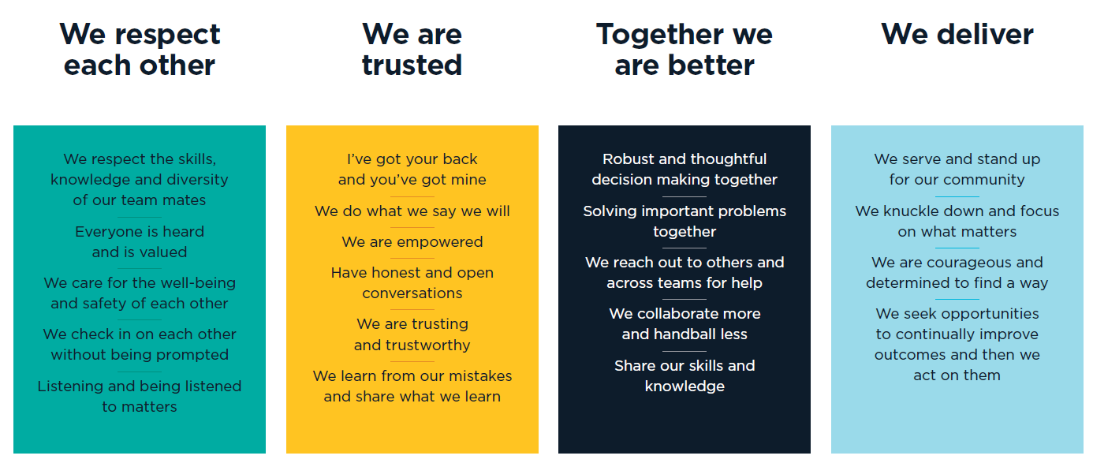

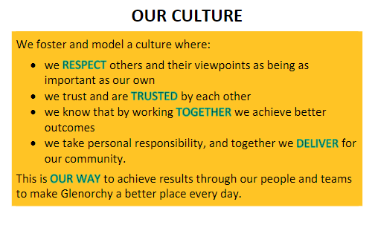

KEY RESPONSIBILITES:

RESPONSIBLITIES/TASKS | DUTIES
Community Development | - Collaborate with other Council staff and key organisations, including schools (public, independent, private), health, services, community houses, local businesses, and sporting clubs in relation to the objectives of the position.  - Develop and utilise external support agencies for referral pathways for young people.  - Identify / develop engagement programs for young people.  - Consult with young people to develop appropriate engagement tools to support Councils Community Engagement Framework.  - Support the Safe City Lead, in working with external support and engagement services within community in the delivery programs as supported by Council.  - Engage with young people through programs and activities.  - Engage with young people to deliver a youth week activity.  - Participate in and/or convene specific working, reference groups, interagency network which address issues and goals identified in delivering on the Community Strategy key focus priority.
Research, report writing, grant submissions and communication | - Conduct research to inform the role of Council.  - Provide support and accurate and timely responses to requests for information both written and verbal.  - Prepare information in plain English and in accordance with Council’s communication and marketing policies and procedures, style guide and access policy and procedures.  - Identify and source grant / funding opportunities.  - Assist in the coordination and preparation of funding submissions for projects and services which address identified needs and service gaps relating to healthy communities.  - Utilise a variety of media in line with Council’s current policies.  - Assist with the development and maintenance of Council’s website, relevant to this position.
Team Work | - Participate in establishing community development principles and practices as part of organisational culture at Glenorchy City Council.  - Utilise Councils Community Engagement Framework and tools.  - Provide positive personal contribution to the successful operation of the Community Department, including working on projects with other team members.  - All members of the Community Department may be required to perform other duties; within the limits of the employee’s skills, competence, and training.
Customer Service | - Promote the positive image of Council as a whole.  - Ensure that a high standard of customer service is maintained to both internal and external customers.  - Engage, listen to and act where appropriate on feedback from our customers.  - Implement, evaluate, and continuously improve quality systems and processes for the section
General | - Assist in the achievement of agreed outcomes consistent with department business plans and budgets.  - Perform any other duties as directed
Organisational Responsibilities | - Support and adhere to Council’s policies and procedures, code of conduct and relevant acts.  - The incumbent is required to commit to use Council’s electronic content management (ECM) system to retain records and documents relating to Council business as part of their employment

This role may require reasonable after-hours activities and overtime when required by business needs.

Employees may be required to undertake additional duties within the limits of their skill, competence, and training, consistent with their classification level, in any area of Council, as directed.

SPECIALIST DELEGATIONS:
- Nil

SPECIAL REQUIREMENTS:
- Driver’s license
- Working with Vulnerable People (WWVP)

KEY SELECTION CRITERIA:
- A tertiary qualification within a related field, with a minimum of three (3) years demonstrated experience in a similar role with knowledge of planning, report writing and project evaluation.
- Understanding of community development principles, trauma informed practice and youth engagement approaches that support community health, wellbeing, and resilience.
- Effective and well-developed stakeholder management communication at all levels with a demonstrated ability to work collaboratively with young people and people who have a diverse range of backgrounds and abilities.
- Demonstrated understanding of the role required to deliver on team priority goals and objectives.
- Effective organisational skills, including the ability to meet deadlines under conflicting pressures while being committed to meeting stakeholder expectations.
- Demonstrated problem solving and decision-making abilities along with the ability to recommend workable solutions.

AUTHORISATION:

I hereby agree that this position description accurately reflects the work requirements.

Manager Name: | Ron Petterson
Manager Signature: |  | Date:
Director Name: | Tracey Ehrlich
Director Signature: |  | Date:

I have read and agree to abide by the requirements of this position description.

Employee Name:
Employee Signature: |  | Date:

