

POSITION DESCRIPTION

Position Title: | Assistant Development Engineer | Directorate: | Infrastructure & Development
Position Number: | To be advised | Department: | Development
Employment Status: | Full-Time | Section: | Planning Services
Employment Type: | Permanent | Location: | Chambers
Classification: | Schedule A, Salary Point 14 (+2) | Location: | Chambers
Reports to: | Development Engineer

PRIMARY PURPOSE:

The role is responsible for assisting with the provision of engineering advice, design, approval and inspection services to further the sustainable development of the City.

ORGANISATIONAL REPORTING RELATIONSHIPS:

- Internal:
- The Assistant Development Engineer reports to the Development Engineer for all operational and management matters.
- The role is a key contributor to the Development Team and will liaise with employees of Council including those responsible for planning, building, and plumbing regulation, development compliance and public asset design and management.

- External:
- The role will liaise with external stakeholders such as developers and their consultants, civil engineers, civil construction contractors, and with ratepayers, residents and the general public.

OUR VALUES:
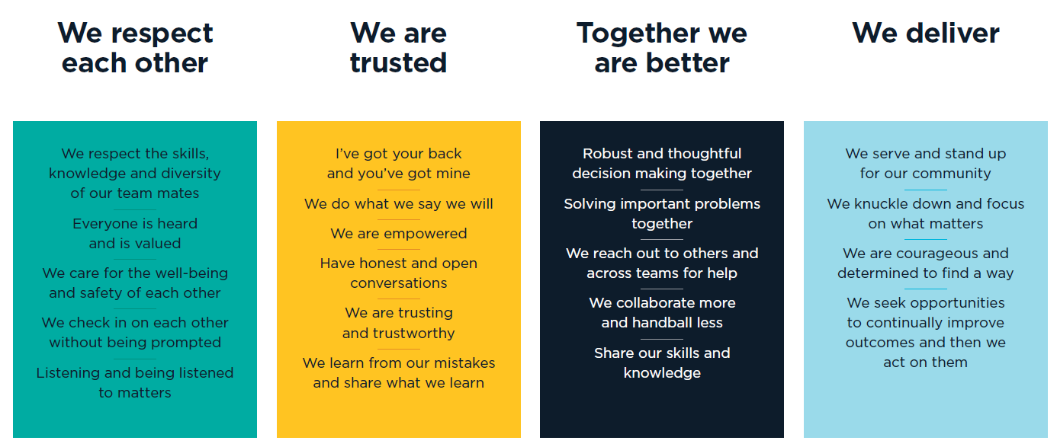

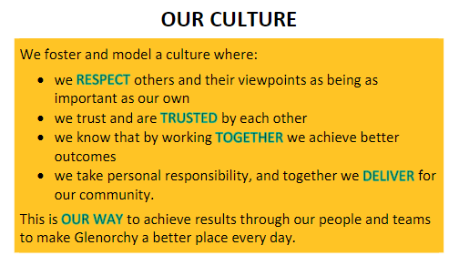

KEY RESPONSIBILITES:

RESPONSIBLITIES/TASKS | DUTIES
Development Engineering | To provide engineering advice and assessment services to further the sustainable development of the City in accordance with present and future community needs including:  - Carrying out engineering assessment of applications for all types of development requiring a planning permit, including requesting and reviewing technical information and formulating conditions to be applied to permits  - Negotiating with developers through the assessment process to ensure engineering outcomes for development are in accordance with Council policies and standards, including Australian Standards  - Assessing engineering design drawings for proposed developments including subdivisions, carparking, vehicle access and stormwater infrastructure against planning scheme and permit requirements and Australian Standards  - Reviewing building permit applications to ensure compliance with the engineering conditions of planning permits and approved engineering design drawings  - Attending and where necessary providing engineering advice at Glenorchy Planning Authority meetings
Engineering Works | To oversee and inspect the construction of civil engineering works by private sector developers, including:  - Inspection of road and stormwater infrastructure  - Inspection of completed driveways, car parking and manoeuvring areas and stormwater works  - Assessment of driveway crossover applications and pre and post pour inspection of driveway/crossover works  - Assessment and inspection of stormwater connections
Customer Service | - Promote the positive image of Council as a whole  - Ensure that a high standard of customer service is maintained to both internal and external customers  - Engage, listen to and act where appropriate on feedback from our customers  - Implement, evaluate and continuously improve quality systems and processes for the section
General | - Assist in the achievement of agreed outcomes consistent with department business plans and budgets  - Perform any other duties as directed
Organisational Responsibilities | - Ensure regulatory functions and enforcement are undertaken in compliance with Council’s policies and procedures and the legislative framework that governs these activities  - Support and adhere to Council’s policies and procedures, code of conduct and relevant acts  - The incumbent is required to commit to use Council’s electronic content management (ECM) system to retain records and documents relating to Council business as part of their employment

This role may require reasonable after-hours activities and overtime when required by business needs.

Employees may be required to undertake additional duties within the limits of their skill, competence and training, consistent with their classification level, in any area of Council, as directed.

SPECIALIST DELEGATIONS:
- Nil

KEY SELECTION CRITERIA:
- Degree in Civil Engineering.
- Experience in a development engineering role and/or experience in the design and construction of public road and/or stormwater assets,
OR
Demonstrated interest and understanding of civil engineering in land and property development and a desire to build a career in this field.
- A commitment to quality customer service, including fostering a culture of customer service excellence.
- An understanding and knowledge of relevant engineering codes, standards and construction practices for road and stormwater assets.
- Demonstrated problem solving and decision-making abilities and the ability to recommend workable solutions.
- Demonstrated ability to work both as part of a team and autonomously on specific projects.

AUTHORISATION:

I hereby agree that this position description accurately reflects the work requirements.

Manager Name:
Manager Signature: |  | Date:
Director Name:
Director Signature: |  | Date:

I have read and agree to abide by the requirements of this position description.

Employee Name:
Employee Signature: |  | Date:

