CREST EDUCATION
Position Description

POSITION SPECIFICATIONS

Position Title | CREST Administrator | Department | Administration
Location | All CREST Education sites, as required | FTE | 1
Position Reports to (title) | Executive Assistant to the Executive Principal | Status | Permanent
Role responsible for the following positions (title/s) | N/A
Approved by | Executive Principal

CREST CONTEXT
CREST Education is an organisation which is values based, empowers leaders, enables people to make a difference and has a culture of learning and high performance in a Christian environment. CREST believes that the values, attributes and skills that each staff member brings to the organisation underpin its culture and will ultimately result in the achievement of CREST’s Pillars.

OUR FOUR PILLARS

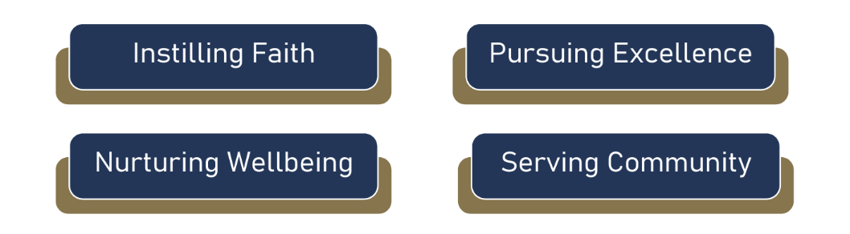

CREST VISION
To be a leading provider of quality Christian Education, delivered by Christian staff, equipping students for a life of faithful service.

KEY SELECTION CRITERIA

Education/Qualifications
- Certificate III or IV in Business Administration, Office Administration, or a related field; or equivalent demonstrated experience
- Previous experience in an administrative, secretarial, or office support role.
- Demonstrated proficiency in Microsoft Office Suite, including Outlook, Word, Excel, and PowerPoint.
- Experience managing confidential information with discretion and professionalism.
- Strong organisational skills with the ability to prioritise competing tasks and meet deadlines.
- Excellent written and verbal communication skills.
- Current First Aid Certificate, or willingness to obtain.
Knowledge & Skills
- Sound knowledge of administrative and office support practices and procedures.
- High level computer literacy with advanced skills in Microsoft Office Suite, particularly Outlook, Word, Excel, and PowerPoint.
- Ability to learn and competently use school management systems and databases such as Synergetic and Crest Connect.
- Strong organisational and time management skills, with the ability to manage multiple priorities and meet deadlines.
- Excellent written and verbal communication skills with the ability to interact professionally with staff, students, parents, contractors, and visitors.
- Strong attention to detail and accuracy in data entry, record keeping, and document preparation.
- Ability to maintain confidentiality and exercise discretion when handling sensitive information.
Other Job-Related Information
- Travel between campuses of CREST Education will be required.
- There may be a requirement to work additional hours from time to time.
- There may be peak periods of work during which taking of leave may be restricted.
- The position will require registration via the Victorian Institute of Teaching (for Teaching roles) or a valid Working With Children Check (for non-teaching roles).
DELEGATED AUTHORITY
- Liaise with staff, contractors, suppliers, and external stakeholders on routine matters as directed by their supervisor.
- Coordinate and administer approved activities, meetings, events, and administrative processes.
- Prepare correspondence, meeting agendas, minutes, reports, and other documentation as required.
- Maintain records, databases, filing systems, and administrative documentation relevant to the role.
- Process routine purchasing, ordering, and invoice administration within approved budgets and delegated processes.
- Access and update relevant College systems and databases required for the performance of the role.
- Escalate urgent operational, safety, or administrative matters to the appropriate supervisor or College leadership.
FINANCIAL DELEGATION OF AUTHORITY
N/A

PURPOSE OF THIS POSITION
The Administration Officer provides high-quality administrative and operational support to ensure the efficient day-to-day functioning of the College. The role supports staff, students, and the wider College community through effective communication, organisation, record management, and coordination of administrative processes and activities. The Administration Officer contributes positively to the mission, values, and culture of Crest Education while maintaining a professional, responsive, and service-focused approach.

STATEMENT OF COMMITMENT TO CHILD SAFETY
All children and young people who come to CREST Education Ltd have a right not only to feel safe, but also to be safe. We are committed to providing a child-safe and child-friendly environment, where children and young people can actively participate in decisions that affect their lives.

We have zero tolerance for child abuse and other harm and are committed to acting in children’s best interests and keeping them safe from harm. The College regards its child protection responsibilities as of prime importance, so we provide the necessary resources both to ensure compliance with all relevant child protection laws and regulations, and also to maintain a child safe culture.

STRATEGIC REQUIREMENTS
At CREST Education, all roles contribute to advancing our strategic priorities of Instilling Faith, Pursing Excellence, Nurturing Wellbeing, and Serving Community. Staff are expected to actively support the integration of Christian faith across all aspects of College life, demonstrate a commitment to continuous improvement and excellence in their practice, foster a safe, inclusive and supportive environment that promotes the wellbeing of students and colleagues, and contribute positively to the life of the College and broader community. Through these priorities, each staff member plays a vital role in shaping a Christ-centred culture that enables every individual to flourish and fulfil their God-given potential.

OPERATIONAL REQUIREMENTS
- Ability and willingness to work collaboratively as part of a team while also operating independently when required.
- Capacity to manage competing priorities, meet deadlines, and maintain accuracy in a busy environment.
- Flexibility to undertake a variety of administrative and operational tasks as directed.
- Ability and preparedness to work outside normal agreed hours to support College events and operational requirements when required.
- Commitment to maintaining confidentiality and handling sensitive information with discretion and professionalism.
- Preparedness to participate in relevant professional learning and development opportunities.
- Commitment to upholding the policies, procedures, mission, and values of Crest Education at all times.
INHERENT REQUIREMENTS | FREQUENCY
 | Unlikely | Possible | Occasionally | Regularly
Passive
Sitting - counter / desk |  |  |  | ●
Sitting – vehicle | ●
Operating telephone / computer |  |  |  | ●
Writing / reading |  |  |  | ●
Spiritual
Leading or taking part in daily devotions with staff and/or students |  |  |  | ●
Leading or taking part in prayer with staff and/or students |  |  |  | ●
Demonstration of our ethos and Fruits of the Spirit: Galatians 5:22 |  |  |  | ●
Incorporating Biblical theology into curriculum | ●
Manual Handling
Bending / twisting Spine |  |  | ●
Working with one or both hands above shoulder height |  | ●
Lifting (5kg or under p/item) | ●
Lifting (5kg or over p/item) | ●
Requiring low/light application of force | ●
Requiring medium to high application of force | ●
Lifting/holding/restraining children | ●
Exerting force in an awkward posture | ●
Holding & supporting equipment |  | ●
Agility
Squatting / kneeling |  |  | ●
Looking up / looking down |  | ●
Reaching forwards or sideways |  | ●
Gripping or grabbing equipment |  | ●
Mobility
Walking / standing- briefly |  | ●
Walking / standing- extended | ●
Walking on uneven ground |  | ●
Climb steps/stairs |  | ●
Driving – passenger vehicle | ●
Driving – light commercial (regular drivers licence) | ●
Driving – bus (endorsed licence) | ●
Driving – machinery/heavy commercial | ●
Sensory
Hearing – face to face / telephone conversations |  |  |  | ●
Hearing – working with loud machinery | ●
Visual – read printed material, signage |  |  |  | ●
Visual – computer screen, electronic signs |  |  |  | ●
Visual – driving |  | ●
Visual – watching with vigilance (e.g. school traffic control) |  |  | ●
Emotional
Dealing with complex stakeholders |  |  | ●
Supporting dependent persons | ●
Dealing with conflict |  |  | ●
Managing complex personal situations |  |  | ●
Providing empathy |  |  |  | ●
Work Environment
Outdoor – exposed to elements, plant & equipment | ●
Confined spaces | ●
Working alone | ●
Working at heights (greater than 2m) | ●
Exposure to extensive dust | ●
Pollen (or other allergens) | ●
Exposure to polluted odours and/or chemicals | ●
Personal waste | ●

LEADERS ONLY



