Position Title: | Customer Services Officer | Position No: | CP 11
Group: | Corporate Services | Service Area: | Learning & Development
Reports to: | Learning & Development Manager | Direct Reports: | Nil
Classification Level |  | Direct Reports: | Nil
Location: | Darwin | Date Approved: | August 2026
Special Measures: | Designated Aboriginal and/or Torres Strait Islander applicants; designated females identified position to support gender equity and providing opportunities for women in the  workforce

POSITION OVERVIEW
The Customer Services Officer provides professional Front Desk Reception and administrative support services for the NLC Darwin Head Office. Under the supervision of the Learning & Development Manager, the role serves as the first point of contact for visitors, employees and stakeholders, ensuring a positive customer experience and the efficient operation of reception services.

KEY RESPONSIBILITIES & ACCOUNTABILITIES

- Support the day-to-day running of the NLC Darwin Head Office reception area including answering phone enquiries, greeting and assisting visitors, directing enquiries appropriately, and managing incoming and outgoing mail, courier services and deliveries.
- Deliver professional, responsive and culturally appropriate customer service to NLC constituents, visitors, contractors and other stakeholders, ensuring enquiries are managed efficiently and referred to the appropriate person or service area.
- Comply with NLC policy and procedures at both an organisational and operational level, ensuring that appropriate standards and operational protocols are maintained for the reception area at all times.
- Perform any other reasonable tasks and duties that are required, that are within the scope of your position classification, service area and skill set as required.
- Follow all NLC policies and procedures to make sure work is carried out to the right standards.
- Take on other reasonable tasks within your role, classification, service area, and skills when needed.
- Follow the NLC Code of Conduct, working in a professional, respectful, and collaborative way with your team and the wider organisation.
- Take part in performance reviews and any learning and development needed for your role.
- Look after your own health and safety and make sure your work does not put others at risk.
- Report any hazards or incidents to your supervisor straight away and complete any required reports on time.
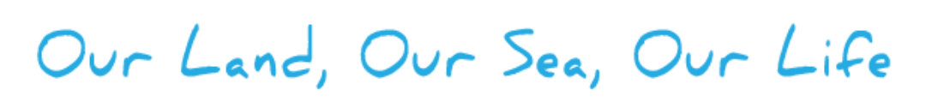

POSITION REQUIREMENTS
ESSENTIAL REQUIREMENTS
- Previous experience in a similar position, or a combination of relevant education, training, and work experience.
- Experience in a front desk, administration or office environment.
- Good attention to detail and a demonstrated ability to work with a range of computer software products, in particular Microsoft Word, Outlook and Teams.
- Communicates confidently and respectfully with people across the organisation, including Traditional Owners (TOs), constituents, and members of the public.
- Organises and prioritises tasks effectively to meet work requirements.
- Demonstrates punctuality and maintains reliable attendance in meeting work commitments.
- Communicates effectively and respectfully with people from diverse backgrounds and builds positive working relationships with colleagues, constituents and external stakeholders.
DESIRABLE REQUIREMENTS
- Current C Class Driver’s license
- Demonstrated understanding of, and interest in, the lived experiences of Aboriginal people in the NLC region.
- Knowledge and understanding of the relevant legislation affecting Aboriginal land and sea management including the Aboriginal Land Rights (Northern Territory) Act 1976 (Cth.) and the Native Title Act 1993 (Cth.)

