Position Title: | Waste Administration Officer | Directorate: | Environmental Services
Position Number: | 100227 | Department: | Sustainability & Environment
Employment Status: | Full-Time | Position Type: | Indoor Employee
Employment Type: | Permanent | Location: | Landfill Offices
Classification Structure: | Grade 2 | Location: | Landfill Offices
Reports to: | Waste Services Coordinator

PRIMARY PURPOSE:
The Administration Officer- Waste provides customer service and administrative functions for the waste services section including Waste, Recycling, FOGO and public litter. This position forms part of Councils commitment to promote waste minimisation and increase recycling rates within the community and forms part of Councils Waste Management Strategy.

ORGANISATIONAL REPORTING RELATIONSHIPS:

- Internal:
- The Waste Administration Officer reports to the Waste Services Coordinator on all operational and management matters.
- The role is a key contributor to the Waste Services Team and will liaise with the Chief Executive Officer, Directors, Managers and all other employees of Council.

- External:
- The role will liaise with external stakeholders such as members of the public, ratepayers, community members, industry suppliers, service providers, visitors and contractors.

Accountabilities And Responsibilities
Administration Support | - To carry out administrative duties relating to the operations of the Waste Services program.  - Maintain records and documentation for waste services and to administer and manage Council’s Waste Services computerised database programs.  - Liaise with Planning & Building section in respect to development applications, new residence approvals, occupancies.  - Liaise with Rates section in respect to waste services charges, including new and/or amended supplementary charges.  - To assist with the management of kerbside recycling, refuse and FOGO collection service and assist with public litter enquiries  - Promotion of waste minimisation and recycling program. To carry out other general administration duties within the Department.  - assisting Waste Services Coordinator in conducting kerbside waste audits, onsite inspections and investigations including FOGO exemptions.
Team Work and Collaboration | - Collaborate with all council employees and proactively share knowledge to help build and maintain skills and capability.  - Perform duties in a manner that fosters cooperation and maintains positive working relationships with team members.  - Show respect for others and their viewpoints, contributing to an inclusive and respectful workplace culture.  - Deliver high-quality, compliant work and advice that earns trust and promotes respect from colleagues and the community.  - Work collaboratively with team members and stakeholders to achieve outcomes effectively and on time.  - Assist in the delivery of daily team operations, participating in team meetings, and allocating work tasks.  - Contribute to an inclusive workplace culture by respecting diverse perspectives and encouraging open, constructive communication  - Take ownership and responsibility for delivering activities that benefit the community and align with council goals, strategic and annual plans.
Customer Service | - Represent the Council in a professional and positive manner  - Ensure that a high standard of customer service is maintained to both internal and external customers.  - Identify and contribute to opportunities for continuous improvement in service delivery.
Organisational Responsibilities | - Take ownership of work priorities to ensure tasks are completed accurately, efficiently, and to a high standard.  - Ensure all assigned work is delivered within agreed timeframes, budgets, and quality expectations.  - Support and promote a diverse and inclusive workplace culture that prioritises the safety and wellbeing of children, young people, the community, and employees.  - Employees may be required to perform additional duties that are within the scope of their skills, competencies, and training, consistent with their classification level. These duties may be undertaken across various areas of the Council, as directed, to support organisational needs and service delivery.  - This role may require reasonable after-hours activities and overtime when required by business needs.
Governance, Risk and Compliance | - Undertake all activities in accordance with Council’s code of conduct, values, policies, procedures, delegations and legal obligations.  - Comply with Work Health and Safety (WHS) policies, procedures and safe work practices.  - Promptly report hazards, incidents, injuries or unsafe practices in accordance with Council requirements.  - Ensure adherence to all relevant legislation, regulations, and organisational standards to maintain compliance with legal, safety, and certification requirements.  - Proactively identify areas of non-compliance and support the implementation of corrective actions.  - Maintain current knowledge and expertise in relevant fields, including awareness of industry best practices and updates to legislative and regulatory frameworks.  - Monitor compliance with applicable Acts, Regulations, and standards to meet legal and certification requirements, report non-conformances and implement corrective actions as needed.  - Participate in professional development and training activities and maintain up-do-date certifications and complete all mandatory compliance and training requirements.

Key Selection Criteria
Essential Qualifications | - Certificate III/IV in Business (Administration) or equivalent experienced in a relevant administrative or a professional office environment.
Licences | - Current registration to work with vulnerable people (RWVP)  - Drivers Licence (preferred but not essential)
Skills and Experience | - Knowledge of Local Government Administration and functions relating to waste management.  - Proven time management and organisational skills that ensures the timely and effective delivery of services and functions relevant to the key duties of the position.  - Demonstrated ability to work as an effective team member in a small discrete unit.  - The proven ability to effectively communicate, both written and oral, with a wide and diverse range of customers.  - High level of ability in the use of Microsoft Office applications, electronic record keeping systems and enterprise systems such as Technology One.

Work Environment
Glenorchy City Council is a values-based organisation, committed to attracting, recruiting, and retaining individuals who uphold our values and actively contribute to the positive culture we aspire to build.
We are dedicated to maintaining high standards of performance in all areas, particularly in relation to Community, Work Health and Safety, Diversity, and Child Safety. All employees are expected to contribute to a safe and inclusive work environment by:
- Promoting and maintaining safe working conditions and practices.
- Supporting fair and equitable access to employment, promotion, training, and personal development.
- Actively working to eliminate workplace harassment and discrimination.
- Ensuring compliance and reporting obligations to safeguard children and young people.
The behaviours and performance standards expected of all Council employees are governed by our Code of Conduct, Workplace Values, Directives and guidelines.
Please note that Glenorchy City Council is a drug, alcohol and smoke-free workplace.
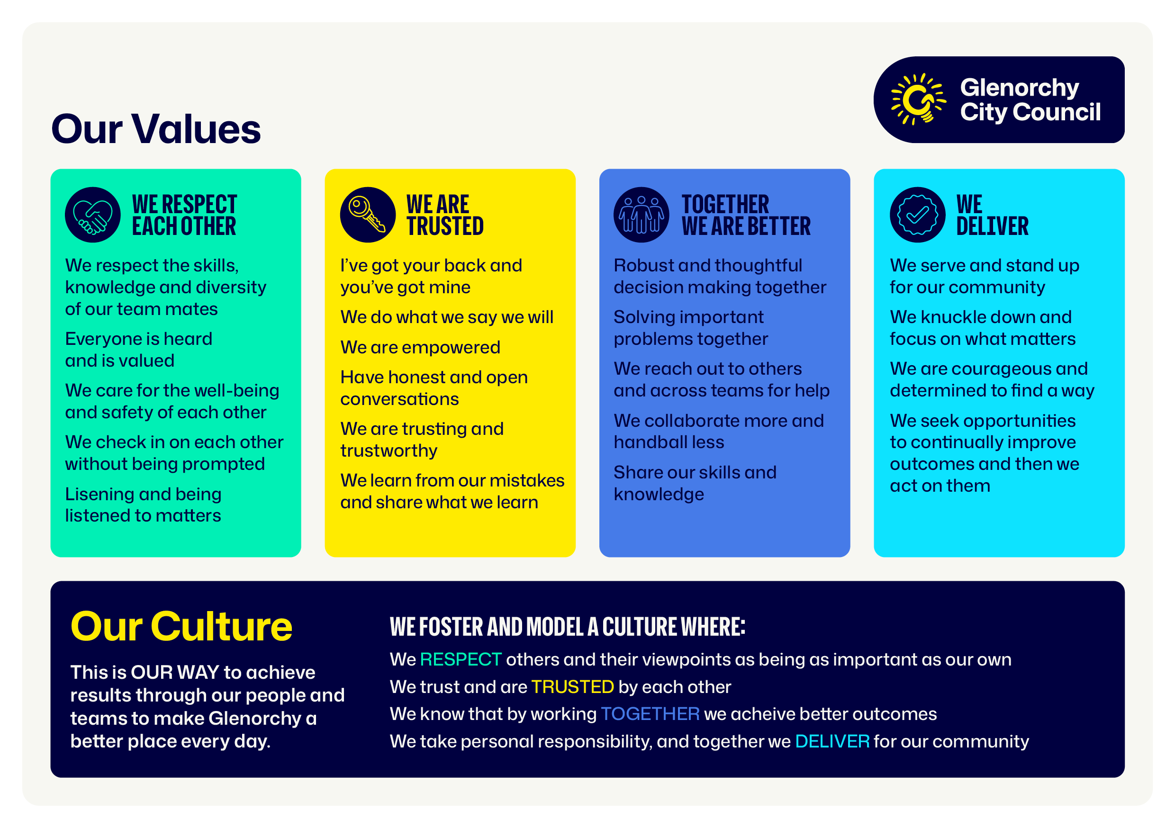

ACKNOWLEDGEMENT:

I have read and agree to abide by the requirements of this position description.

Employee Name:
Employee Signature: |  | Date:

