VOLUNTEER

INDUCTION

HANDBOOK

“To bring up children properly we must love them; we must love them all equally.
To love the children is to devote oneself completely to teaching them and to take all the
means that an industrious zeal can think of in order to form them in virtue and piety.”
Saint Marcellin Champagnat

Contents
VOLUNTEER 1
INDUCTION 1
HANDBOOK 1
PRINCIPAL’S WELCOME 3
VOLUNTEERING AT MARCELLIN COLLEGE 4
CHILD SAFEGUARDING 5
OCCUPATIONAL HEALTH AND SAFETY 7
EVACUATION PROCEDURES 8
Evacuation 8
FIRST AID AND MEDICAL TREATMENT 10
OHS SAFETY INCIDENT FORM: STAFF, VISITORS AND VOLUNTEERS 10
SAFETY INCIDENT FORM: STUDENT INJURY 10
ANAPHYLAXIS 11
WHAT IS ANAPHYLAXIS? 11
VOLUNTEERS RESPONSIBILITIES: TREATMENT OF ANAPHYLAXIS 11
TREATMENT OF ANAPHYLAXIS 11
HOW TO ADMINISTER AN ADRENALINE (EPINEPHRINE) AUTOINJECTOR 12
How to give Anapen® 12
How to give EpiPen® 12
FREQUENTLY ASKED QUESTIONS 13
When can I start Volunteering at the College? 13
What do I need to do when I arrive at the College as a Volunteer? 13
What do I do if I am unable to make my rostered day? 13
What do I do if I have sustained an injury on College grounds? 13
What do I do if I can no longer Volunteer? Who should I inform? 13
Who do I contact if I have a query not covered by this FAQ? 13
VERSION CONTROL TABLE 14

PRINCIPAL’S WELCOME

Dear Volunteers,
“Everybody can be great because anybody can serve. You only need a heart full of grace. A soul generated by love.” - Martin Luther King Jr.

I would like to warmly welcome you as a valued member of the Marcellin College family. Thank you for accepting the invitation to volunteer within our College community. Your generosity of time and spirit is deeply appreciated and I sincerely hope your experience here is as enriching for you as your presence will be for our young men.
Marcellin College was founded on the educational and spiritual philosophy of Saint Marcellin Champagnat. Every policy, program and interaction within our College is shaped by the Marist Charism, which calls us to live and lead with purpose. Central to this is our commitment to the Marist HEART values of Humility, Excellence, Acceptance, Resilience and Trust.
- Humility calls us to serve with generosity, placing the needs of others before ourselves and recognising the dignity of every individual.
- Excellence challenges us to give our very best in all that we do, striving to nurture the potential of each young man entrusted to our care.
- Acceptance reminds us that we are called to welcome and respect all, creating an inclusive community where everyone feels known, valued and safe.
- Resilience encourages perseverance, courage and hope, especially in times of challenge or uncertainty.
- Trust underpins our relationships, fostering honesty, integrity and mutual respect across our community.
The Marist educational philosophy challenges us to build strong, respectful and pastoral relationships with our students. Saint Marcellin Champagnat believed that to educate young people, we must love them and love them all equally. This spirit is further expressed through the five Characteristics of the Marist Charism: Presence, Simplicity, Love of Work, Family Spirit and In the Way of Mary. These characteristics serve as guiding signposts as we journey alongside our young men throughout their years at the College.
Saint Marcellin believed the strength of a Marist community lies not only in unconditional respect for young people, but also in the cultivation of supportive and life-giving relationships among all members of the community. As volunteers, you are now part of this shared mission. I encourage you to seek the collegial support of fellow Marists here at Marcellin College, as together we live out our HEART values and work in solidarity as co-creators of a vibrant and faith-filled College community.
Through your support of the College, you become a source of Living Water, bringing life, hope and encouragement to those around you. Thank you for modelling Christian service and for helping us to form young men of faith, character and compassion.
With my best wishes,
Marco Di Cesare
Principal

VOLUNTEERING AT MARCELLIN COLLEGE
Marcellin College values the integral role Volunteers play in supporting our young men during their time at the College. The Volunteers in our community have established a proud link between families, students and the College which continues to provide enormous benefits.
- Business & Community Network
- Canteen
- Friends of Music & Performing Arts (FOMPA)
- Parents & Friends Group
- Second Hand Uniform Shop
- Sport

Please refer to your engagement pack for Position Descriptions which outline the various duties our volunteers undertake in the roles above.

WHAT DOES YOUR FIRST DAY LOOK LIKE?
On your first day, volunteers will meet the lead (manager) of the area in which they are helping. The lead will run through a brief induction to ensure the volunteer is confident with the role they have, that logistical items have been covered (i.e., parking, bathrooms, etc.) and that the volunteer is fully equipped to undertake the tasks provided.

CHILD SAFEGUARDING
All children and young people who come to Marcellin College have a right to feel and be safe. We’re committed to child safety and wellbeing and to creating and maintaining a child safe and child-friendly environment.
Each member of the College community has a responsibility to understand the important and specific role that they play individually and collectively to ensure the wellbeing and safety of all students is at the forefront of all they do and every decision they make.
Before commencing any volunteer duties with the College, you must read and acknowledge the following documents relating to Child Safeguarding which are part of an onboarding pack.
- Marist Child Safe Adult Code of Conduct
- Staff and Student Professional Boundaries
- Volunteers Responsibilities
- Child Safeguarding Policy

Our Child Safeguarding Officers can also assist you in understanding your reporting obligations and answer any questions you may have about the College’s Codes of Conduct and Child Safeguarding Program more generally. Reporting to or consulting with a Child Safeguarding Officer does not change any obligations you have under legislation to report to an external authority.

If you have a belief or suspicion that a child is being, or has been, subjected to any form of abuse you must contact the Department of Families, Fairness and Housing (Child Protection).

Where you need guidance on making a report or have questions regarding child safety and wellbeing, contact one of the College’s Child Safeguarding Officers.

Whenever there are concerns that a child is in immediate danger, call the Police on 000.

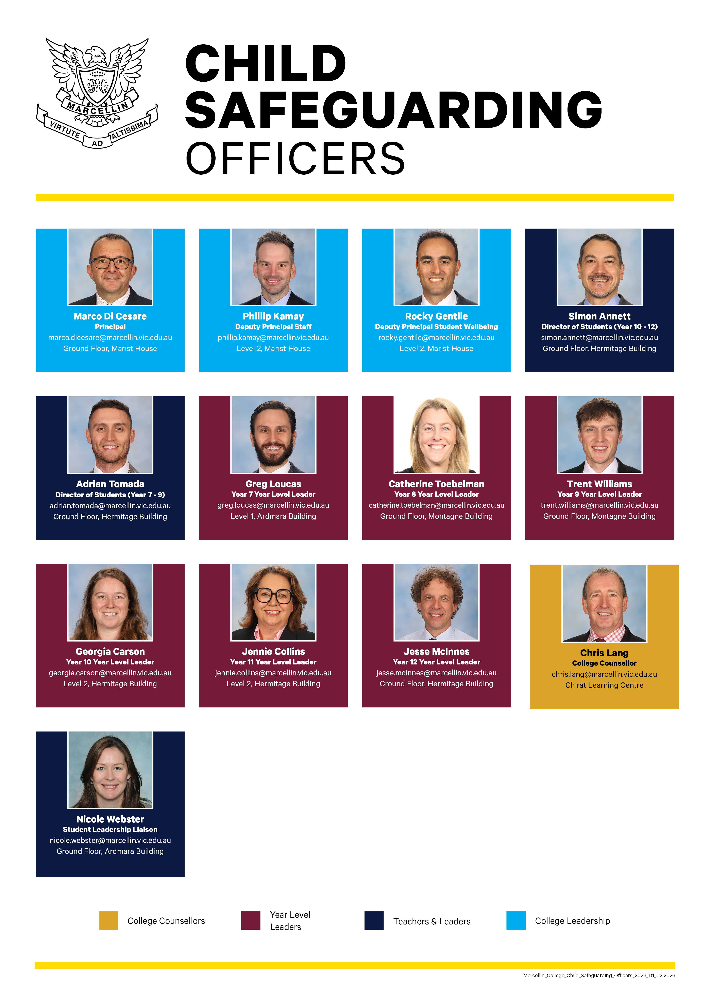

OCCUPATIONAL HEALTH AND SAFETY
The Occupational Health and Safety Act 2004 is the main workplace health and safety law in Victoria. It sets out the key principles, duties and rights about occupational health and safety (OHS).
Marcellin College is committed to the provision of a safe and healthy work environment for all students, staff, contractors, visitors and volunteers. The College’s Occupational Health and Safety Policy can be found at the following link: Click Here
All staff – including volunteers – are encouraged to provide input and feedback on the safety of our workplace, including our OHS and Injury Management and Return-to-work programs. The best way to do this is to engage with a representative of our OHS Committee or send an email to ohs@marcellin.vic.edu.au.
Our OHS Committee meets once per term to discuss OHS matters. These meetings involve:
- discussing any OHS matters brought to the attention of Committee Members, either through their own observations or via staff input
- reviewing the number, nature and severity of OHS Incident Notifications
- considering what measures can be put in place to reduce the risk of incident recurrence and tracking the implementation of those measures

2026 COMMITTEE MEMBERS
NAME | TITLE | ROLE
Phillip Kamay | Deputy Principal Staff | Co-Chair
Peita Smith | Compliance Officer | Co-Chair
Mya Serdar | Human Resources Officer | Secretary
Rocky Gentile | Deputy Principal Student Wellbeing | Committee member
Johnny Tran | Business Manager | Committee member
James Allsop | Facilities Manager | Committee member
Eryn Seach | College Nurse | Committee member
Grace Florio | Library Technician & HSR | Committee member
Luke Corcoran | Teacher | Committee member

EVACUATION PROCEDURES
The College is committed to ensuring the safety, health and wellbeing of its staff, students, parents, carers, volunteers, contractors and visitors. The College has Emergency and Security Management Systems in place. As a Volunteer, it is your responsibility to familiarise yourself with the College’s Emergency procedures.
A summary of Emergency Procedures and Evacuation Plans are located within buildings throughout the school.
All incidents likely to affect the safety and well-being of students, teachers or visitors should be reported immediately to the front office in person or by calling Main Reception. The safety and well-being of all community members exposed to the emergency are considered at all stages of the emergency.
NOTE: In classrooms and all public areas there are maps showing your location and evacuation assembly areas; Gartner Fields (primary evacuation area) and St Marcellin’s Hall (secondary evacuation area).

Evacuation
In the case of either a partial or full evacuation it is important that all members of the community are aware of what they must do.
If an evacuation is required, the following steps may be taken.
- There will be evacuation tones sounded over the PA system with instructions from either the Chief Warden or Communications Officer.
- If an evacuation (partial or full) is required, then the “whoop whoop” tone will be sounded. Listen for instructions over the PA at this time.
- As directed by the Chief Warden or Communications Officer all teaching staff will evacuate the buildings and make their way down to either the Gartner Fields (primary evacuation area) or St Marcellin’s Hall (secondary evacuation area).
Volunteers should follow the instructions over the PA and move to the evacuation area and report to the Communications Officer (identified by wearing the white hat).
- School officers have been trained as Wardens and will enact their role within the evacuation (i.e. report to Student Services if safe to do so).
- All staff, visitors, volunteers and contractors must follow the direction of the Wardens during any emergency.

With any evacuation, all members of the community onsite must wait until the ‘all clear’ is given by the Chief Warden before returning to their classroom or area of work.
The Primary Evacuation Assembly Area is located at Gartner Fields. This location is displayed below:
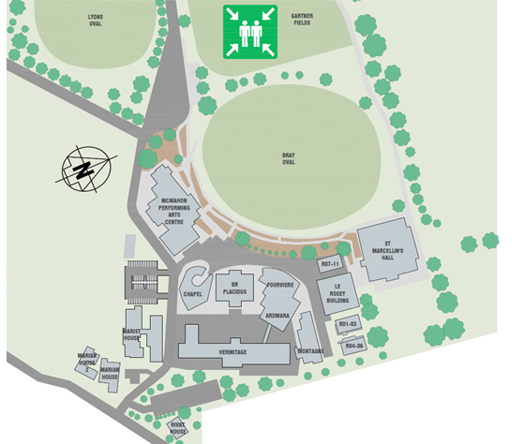

FIRST AID AND MEDICAL TREATMENT
First aid provides the initial and immediate attention of a person suffering an injury or illness and in extreme cases, a quick first aid response could mean the difference between life and death.
In many cases, first aid can reduce the severity of the injury or illness as quick and competent first aid calms the injured person and reduces unnecessary stress and anxiety.
First aid kits are located throughout the College. The First Aid Room is located at Student Services in the Hermitage Building. In the event of serious injury, where emergency medical assistance is required, an ambulance should be called by dialling 000.

OHS SAFETY INCIDENT FORM: STAFF, VISITORS AND VOLUNTEERS
This online form is to be used by staff, visitors and volunteers for all OHS incidents and near misses. Your notification will be managed in accordance with the College’s OHS Program.
This form can be accessed online via the following link: Click here.

SAFETY INCIDENTS: STUDENT INJURY
Staff, visitors, and volunteers are required to report all student injuries. All notifications will be reviewed and managed by the College Nurse and the Pastoral Care team.

Please ensure that all student injuries are also recorded in the College’s Learning Management System, Compass, in accordance with College procedures. These entries should be completed in conjunction with the Volunteer Lead (Manager).

ANAPHYLAXIS

WHAT IS ANAPHYLAXIS?
Anaphylaxis is the most severe form of allergic reaction. Individuals can have a mild, moderate or severe allergic reaction. Anaphylaxis is a severe, rapidly progressive allergic reaction that is potentially life-threatening. The most common allergies in school-aged children are peanuts, cow’s milk, egg, tree nuts (e.g. cashews and walnuts), wheat, soy, sesame and certain insect bites and stings (particularly bees, wasps, ants and ticks).
The key to prevention of anaphylaxis in school is knowledge of students who have been diagnosed as at risk, awareness of allergies and prevention of exposure to those triggers that cause allergic reactions.
The College has an Anaphylaxis Management Policy and continues to review and maintain this Policy in line with the Anaphylaxis Guidelines for Victorian Schools and Ministerial Order No. 706: Anaphylaxis Management in Victorian schools and school boarding premises.

VOLUNTEERS RESPONSIBILITIES: TREATMENT OF ANAPHYLAXIS
- If possible, the volunteer should seek immediate help from a Marcellin College staff member. All teachers have been trained in anaphylaxis management.
- If possible, the volunteer should contact the College Nurse
- If there are no Marcellin College staff in the proximity the volunteer should administer the adrenaline (epinephrine) autoinjector and call 000 immediately.

TREATMENT OF ANAPHYLAXIS
Adrenaline given through an adrenaline (epinephrine) autoinjector (such as an EpiPen® or EpiPen® Jr) into the muscle of the outer mid-thigh is the first aid treatment for anaphylaxis. Adrenaline autoinjectors are designed for use by laypeople.
This is what Anapens and EpiPens look like:
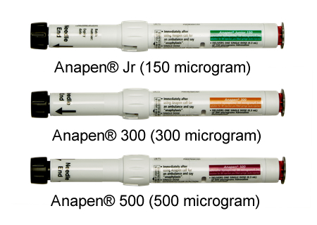 | 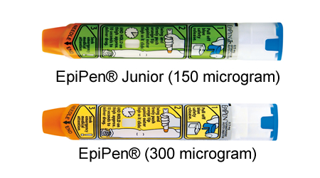

HOW TO ADMINISTER AN ADRENALINE (EPINEPHRINE) AUTOINJECTOR
How to give Anapen®  Adrenaline (epinephrine) autoinjectors | How to give EpiPen®  Adrenaline (epinephrine) autoinjectors
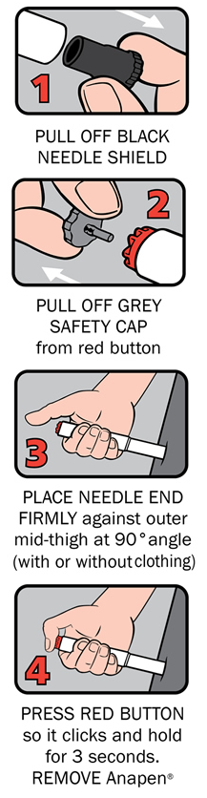 | 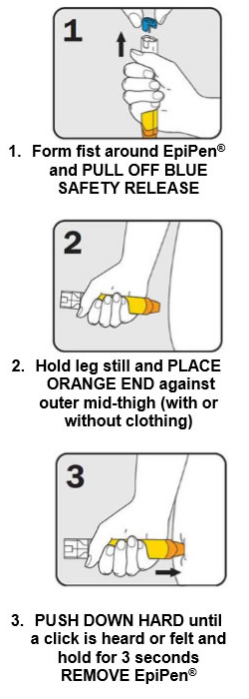
After Anapen® is used, put it to one side and do not touch the exposed needle.  After phoning ambulance, place needle into wide end of the black needle shield, or place the used Anapen® in a container. Provide ambulance with the used Anapen® and the time it was given.  A short animated video on how to give Anapen® is available on the Allergy & Anaphylaxis Australia website:  https://allergyfacts.org.au/resources/videos-from-a-aa#anapgive | Provide ambulance with the used EpiPen® and the time it was given.  A short animated video on how to give EpiPen® is available on the Allergy & Anaphylaxis Australia website:  https://allergyfacts.org.au/resources/videos-from-a-aa#epiadmin

FREQUENTLY ASKED QUESTIONS

When can I start Volunteering at the College?
Once you have completed all the relevant checks and training depending on the area you have nominated to volunteer in, the designated supervisor will contact you directly to discuss a start date and where to go on your first day.

What do I need to do when I arrive at the College as a Volunteer?
On a rostered day, each volunteer will sign in as being present on school grounds, using the Compass Kiosk located at Main Reception in Marist House, collect a lanyard and wear it for the duration of their time.
Canteen volunteers must also sign in as being present using the sign on method at the canteen and wear a volunteer lanyard.
Sport Volunteers, sign in as being present using the Sine Pro app on their mobile phones and wear the volunteer lanyard.
To download the Sine Pro app, click https://marcellin.vic.edu.au/checkin/ or scan the QR code provided by the Team Coach.

What do I do if I am unable to make my rostered day?
Let your supervisor know if you will not be available as soon as possible so other arrangements can be made. Alternatively, phone College reception on 9851 1589 and they will pass on the message.

What do I do if I have sustained an injury on College grounds?
You will need to advise your supervisor and complete the Safety Incident Form contained in this Handbook and forward to your supervisor. Your supervisor will arrange for the details to be recorded in our online injury register.

What do I do if I can no longer Volunteer? Who should I inform?
Please advise your supervisor if you are no longer available to volunteer.

Who do I contact if I have a query not covered by this FAQ?
All questions relating to your volunteer role and duties should go directly to your supervisor.
For all queries regarding the volunteer process or program, you can contact Human Resources via volunteers@marcellin.vic.edu.au or 9851 1589.

VERSION CONTROL TABLE
Title | Volunteer Induction Handbook
Sphere | Leadership and Management
Intended Audience | Community
Author | Deputy Principal Staff
Document Ratified | 2019
Document Updated | 2020 – minor update  2021 – major update to include update to Principal’s Welcome, Child Safeguarding Officers, First Aid Procedure, Safety Incident Form, FAQs  2022 – major update  2023 – minor update  2024 – minor updates  2026 – minor updates
Review Date | February 2027

