1. JOB IDENTIFICATION:

Title of Position: TEAM LEADER COMMUNITY & CULTURAL DEVELOPMENT
Business Unit: COMMUNITY CONNECTIONS
Reports to: MANAGER COMMUNITY CONNECTIONS
Classification: MOA 8

2. POSITION OBJECTIVES:

The Team Leader Community & Cultural Development provides leadership and direction across Council’s multi-disciplinary community services portfolio, ensuring high-quality strategies, projects, programs and facilities that build community capacity, foster inclusion, and enhance community wellbeing and vitality.

The role will:
- Lead and support a high-performing, collaborative and engaged team.
- Oversee the delivery of services, programs, facilities and strategies across:
  - Community Centres and Community Facilities Hire
  - Social Planning, Community Funding and Strategic Partnerships
  - Community Inclusion, including but not limited to youth, ageing, disability access and inclusion, Reconciliation
  - Arts, Culture, Events and Activation
  - Recreation, Sport and Volunteering
- Provide expert advice on community and cultural development, social planning, and facility management to anticipate and respond to emerging community needs.
- Ensure services, programs, and facilities are accessible, inclusive, innovative, and responsive, delivering maximum value to the community.
- Secure and manage external partnerships, sponsorships, and grant funding.
- Drive continuous improvement, business efficiency, and innovation across all areas of responsibility.

- KEY RESPONSIBILITIES:

- Lead and manage staff in-line with the City of Unley’s Leadership Capability Framework and organisational values, ensuring clear direction, development, performance management, and succession planning.
- Deliver the team’s annual work plan within time, budget, and resource constraints, with a focus on community value.
- Ensure effective management of Council’s community centres and facility hire services, including the Clarence Park partnership agreement and the Unley Community Hub.
- Oversee the development, implementation, and evaluation of community strategies, policies, plans, and initiatives (e.g. Disability Access and Inclusion Plan, Public Health Plan, Reconciliation Action Plan).
- Oversee events, activations, arts, culture, recreation, and volunteer programs to strengthen community participation and engagement.
- Build and maintain strong partnerships with internal stakeholders, community organisations, state and federal agencies, peak bodies, and funding partners.
- Provide strategic advice to Council on community development, inclusion, and wellbeing trends and emerging needs.
- Lead the promotion of community services, programs, and facilities, ensuring strong visibility, participation, and storytelling.
- Secure, manage, and report on external funding, grants, and sponsorships.
- Prepare and manage budgets, financial reports, and business improvement processes.
- Represent Council at meetings, forums, committees, and working groups.
- Ensure compliance with legislation, policies, contracts, and accreditation requirements (e.g. Australian Service Excellence Standards).
- Other duties as required.

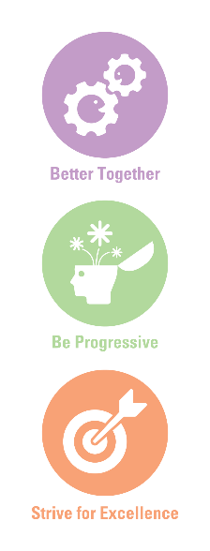
Staff must comply with WHS and Return to Work SA legislation requirements and relevant WHS policies, procedures and safe work practices implemented by the City of Unley.

Key WHS Responsibilities:
- Actively support and contribute to the City of Unley’s effective safety culture.
- Identify and report health and safety hazards, accidents, incidents, injuries and property damage within the workplace.
- Taking reasonable care to ensure their own safety and not placing others at risk, including appropriate use of equipment and PPE.
- Complying with the requirements of the City of Unley’s WHS management system.
- Attending WHS training and following instructions and advice provided.

SAFE ENVIRONMENT:
- Comply with the City of Unley Safe Environment policy and all relevant policies and procedures.
- Notify the Department of Human Services if, on reasonable grounds, you suspect that a child has been or is being abused or neglected if the suspicion is formed in the course of your work while carrying out official duties.
- Notify the Department of Human Services if, on reasonable grounds, you suspect that an aged and/or vulnerable person has been or is being abused or neglected if the suspicion is formed in the course of your work while carrying out official duties.
- Seek advice and support from your Team Leader, Manager or the People & Culture team if a notification is required.
- Advise your Team Leader, Manager or the People & Culture team if there is a change in your criminal history status and undertake a Department of Human Services Screening every three or five years (time frame is related to specific clearance type), unless more regular screening is required for legislative purposes.

EQUAL OPPORTUNITY EMPLOYMENT
Contribute to the promotion and adherence of the employee conduct standards and in particular Equal Opportunity by adhering to the provisions of relevant legislative requirements.

Actively support and contribute to the City of Unley’s organisational values.

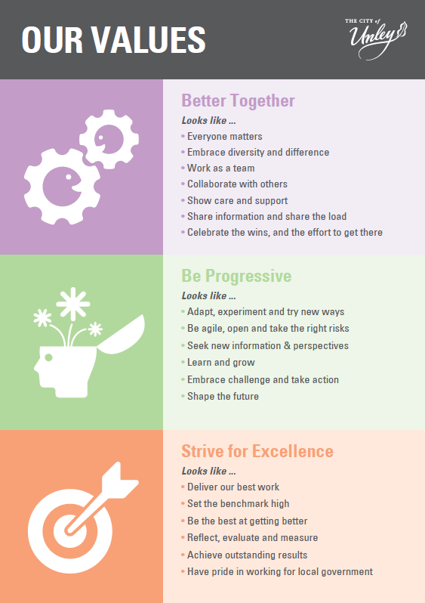

4. PERFORMANCE AND SKILL REQUIREMENTS:
a) Qualifications/Experience

- Tertiary qualification in community development, social planning, social sciences, or extensive relevant experience.
- Current DHS Working with Children check.

Driver’s licence (C Class).
NOTE: Copies of the above-listed qualifications/licences/certificates are required as evidence on appointment.

- Proven leadership experience within local government or the community sector.
- Experience managing, developing, and mentoring staff.

Experience in managing or delivering diverse community programs, functions and strategies.

Demonstrated success in securing and managing external funding.
- Experience with project management frameworks.

b) Knowledge

- Understanding of local government’s role in community development, facility management, cultural planning, and service delivery.
- Principles and best practice in community development and facilities, engagement, inclusion, and social planning.
- Current federal, state, and local government policies and trends in community-based programs, cultural services, recreation, and social wellbeing.
- Human resource management principles.
- Knowledge of funding sources, community resources, and partnership models.
- Familiarity with promotional and engagement tools (e.g. Bookable, Eventbrite, Your Say, Mailchimp).
- Understanding of relevant legislation and governance requirements.

c) Skills

- Developed leadership and people management skills, with ability to influence, motivate, and collaborate across diverse stakeholders.
- Strategic planning, policy, and report-writing expertise.
- Highly developed communication skills (verbal, written, public speaking, presentations, media).
- Well-developed partnership, negotiation, and advocacy skills.
- Effective budget preparation, monitoring, and financial management.
- Proficiency in Microsoft 365 and digital technologies.
- Well-developed organisational and project management skills, with ability to manage competing priorities.
- Skills in marketing, communications, and digital engagement.

d) Personal Attributes
- Self-directed, innovative, and accountable.
- High integrity, discretion, and professionalism.
- Approachable and open, with ability to work across diverse communities.
- Commitment to continuous improvement, professional development, and lifelong learning.
- Flexible and willing to work outside normal hours when required.

By signing this position description, the employee and the employee’s manager agrees that it is an accurate reflection of the responsibilities and requirements of the position:

Incumbent: ........................................................ Date: .............................

Manager: ........................................................ Date: ..............................

