Position Title: | Ranger Coordinator Wagiman | Position No: | NT72
Group: | Land and Sea Management | Service Area: | Caring for Country
Classification Level: | Administration Service Officer 6 (ASO6)
Reports to: | Regional Program Coordinator- Victoria River District (VRD) (NT72) | Direct Reports: | Ranger Group
Special Measures: | Priority consideration for Aboriginal and/or Torres Strait Islander applicants
Location: | Pine Creek /Lewin Springs Ranger Base. | Date Approved: | September 2025

POSITION OVERVIEW
The Ranger Coordinator is responsible for leading the Wagiman Ranger Group and ensuring the effective delivery of land and freshwater management activities. The position is responsible for the supervising, mentoring and developing local rangers to achieve the aspirations outlined in the Wagiman Healthy Country Plan 2024-2034. A core function of the role is implementing and reporting on the Wagiman rangers five (5) year workplan, ensuring activities are delivered on time, within scope and to a high standard.

Reporting to the Regional Program Coordinator, you will work closely with the CFC program support staff, to ensure that Traditional Owner (TO) knowledge and priorities are integrated into all operations while maintaining high standards of Work Health and Safety (WH&S). The Ranger Coordinator also has accountability for fostering a culture of safety, wellbeing and asset management, ensuring all activities are compliant with WH&S policies and procedures and legislative requirements.

KEY RESPONSIBILITES AND ACCOUNTABILITIES
LEADERSHIP
- Lead by example and demonstrate commitment to the Unit’s service delivery in alignment with NLC’s vision, mission, values and business priorities.
- Actively contribute to the overall culture of the NLC by adopting the principles of the NLC People Centred Care and Leadership model, enabling positive contributions to enhance employee engagement and job satisfaction within the unit.
- Lead, motivate, develop, and empower team members to deliver in accordance with the unit’s priorities, and section area objectives, within a framework that drives accountability and achievement.
- Ensure unit staff have a clear understanding of their responsibilities, and encourage open and honest, two-way communication at all levels.
STAKEHOLDER RELATIONSHIPS
- Cultivate and maintain collaborative relationships with Traditional Owners (TOs) to support the NLC TO centric relationship model and unit deliverables.
- Build and maintain relationships with all relevant government agencies and other internal and external stakeholder to ensure compliant and effective delivery of unit service deliverables.
- Actively assist and implement any authorised operational change in order to facilitate ongoing stakeholder commitment to outcomes.
UNIT OPERATIONS
- Lead, coordinate and monitor the unit’s operational service outcomes and performance in accordance with Wagiman rangers operational work plans and requirements.
- Consult with Traditional owners and NLC constituents to develop, implement and deliver on Wagiman ranger group’s annual work plans.
- Supervise all operational works but not limited to:
- Water management activities
- Fire management activities
- Biodiversity surveys
- Feral animal surveys
- Purchasing and asset management
- Maintenance of ranger base
- Fee for service contracts
- Provide the appropriate level of supervision, support, guidance, mentoring and operational processes to support unit and staff performance to standards required.
- Ensure all team members are adhering to all relevant compliance, governance, legislative and organisational requirements and standards.
- Maintain unit associated administrative and record keepings task to standard.
- Complete all unit performance reporting and other reporting requirements to standard and within required timeframes.
PEOPLE MANAGEMENT
- Foster and maintain a People Centred Care management culture ensuring all people management practices are adhered to in accordance with our leadership model, policy, process under the guidance of senior leadership and P&C Advisory services.
- Maintain accountability and responsibility for:
- Recruitment of vacant positions in the section
- The performance management of direct reports in accordance with the position requirements and NLC's organisational objectives
- The rostering of resources, timesheets and leave approval
- Actively supporting relevant Learning and development activities to enhance the service delivery of your team
- Assist with the implementation of key transformative people related initiatives that are designed to guide the NLC into a space of contemporary and culturally safe practice whilst the NLC strives to realise its ‘Activating Land and Sea Rights’ and ‘Building the Bush’ strategies.
WORK HEALTH AND SAFETY
- Lead by example and cultivate a work culture and environment that prioritises the wellbeing, health and safety of our staff people centred care and leadership framework.
- Maintain unit compliance and provide a safe working environment in accordance with, the NLC WH&S Management System and associated policies, procedures and plans ensuring you are fulfilling your duty of care in accordance with the legislative requirements.
- Actively support the review and investigation of critical as well as non-critical incidents and other hazards or risks identified in a timely manner.
- Promote and support organisational work health and safety initiatives
- Maintain asset management practices in line with NLC requirements.

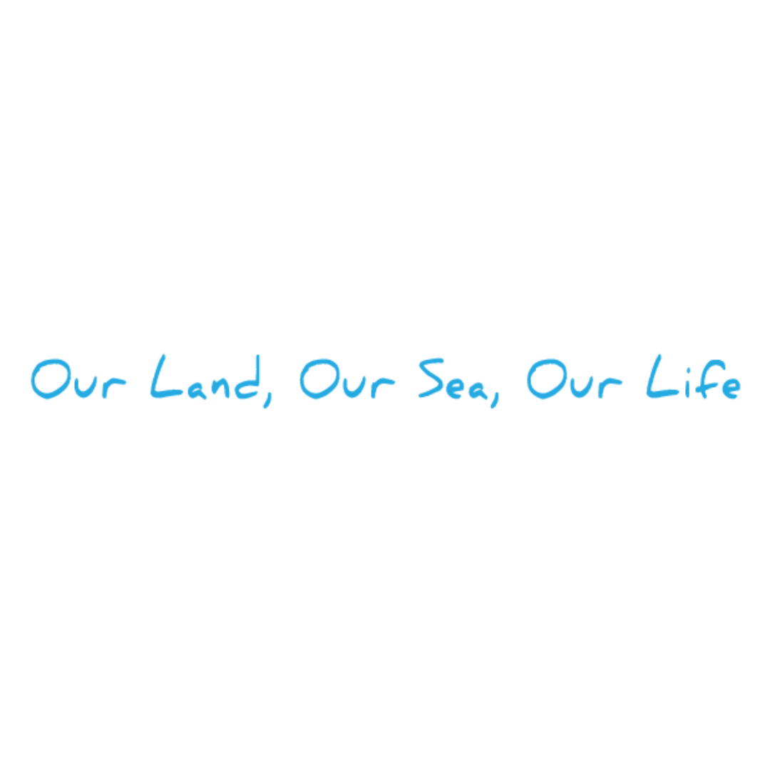

POSITION REQUIREMENTS
ESSENTIAL REQUIREMENTS
- Minimum Certificate IV in Conservation and Ecosystem Management or a relevant field and/or two (2) years relevant experience in a similar role.
- Previous experience managing program WHS and assets in a remote setting.
- Demonstrated organisational, time and people management skills, with the ability to manage multiple tasks and priorities.
- Minimum of 2 years’ experience leading and motivating a small team.
- Demonstrated experience in the delivery of fire and other land management programs.
- Sound knowledge and understanding of Aboriginal land management practices and cultural protocols.
- High level cross-cultural, interpersonal and verbal communication skills with an ability to effectively liaise, engage and coordinate across an organisation and to build productive working relationships with work colleagues, constituents and external stakeholders.
- Sound computer literacy skills in Microsoft Office Suite including basic mapping and GIS systems.
- A current NT drivers’ licence (manual) plus experience in undertaking remote 4WD vehicle travel and light aircraft work.
DESIRABLE REQUIREMENTS
- Demonstrated experience/and or understanding of the Healthy Country Planning (HCP) standards.
- Ochre Card and or ability to acquire.

