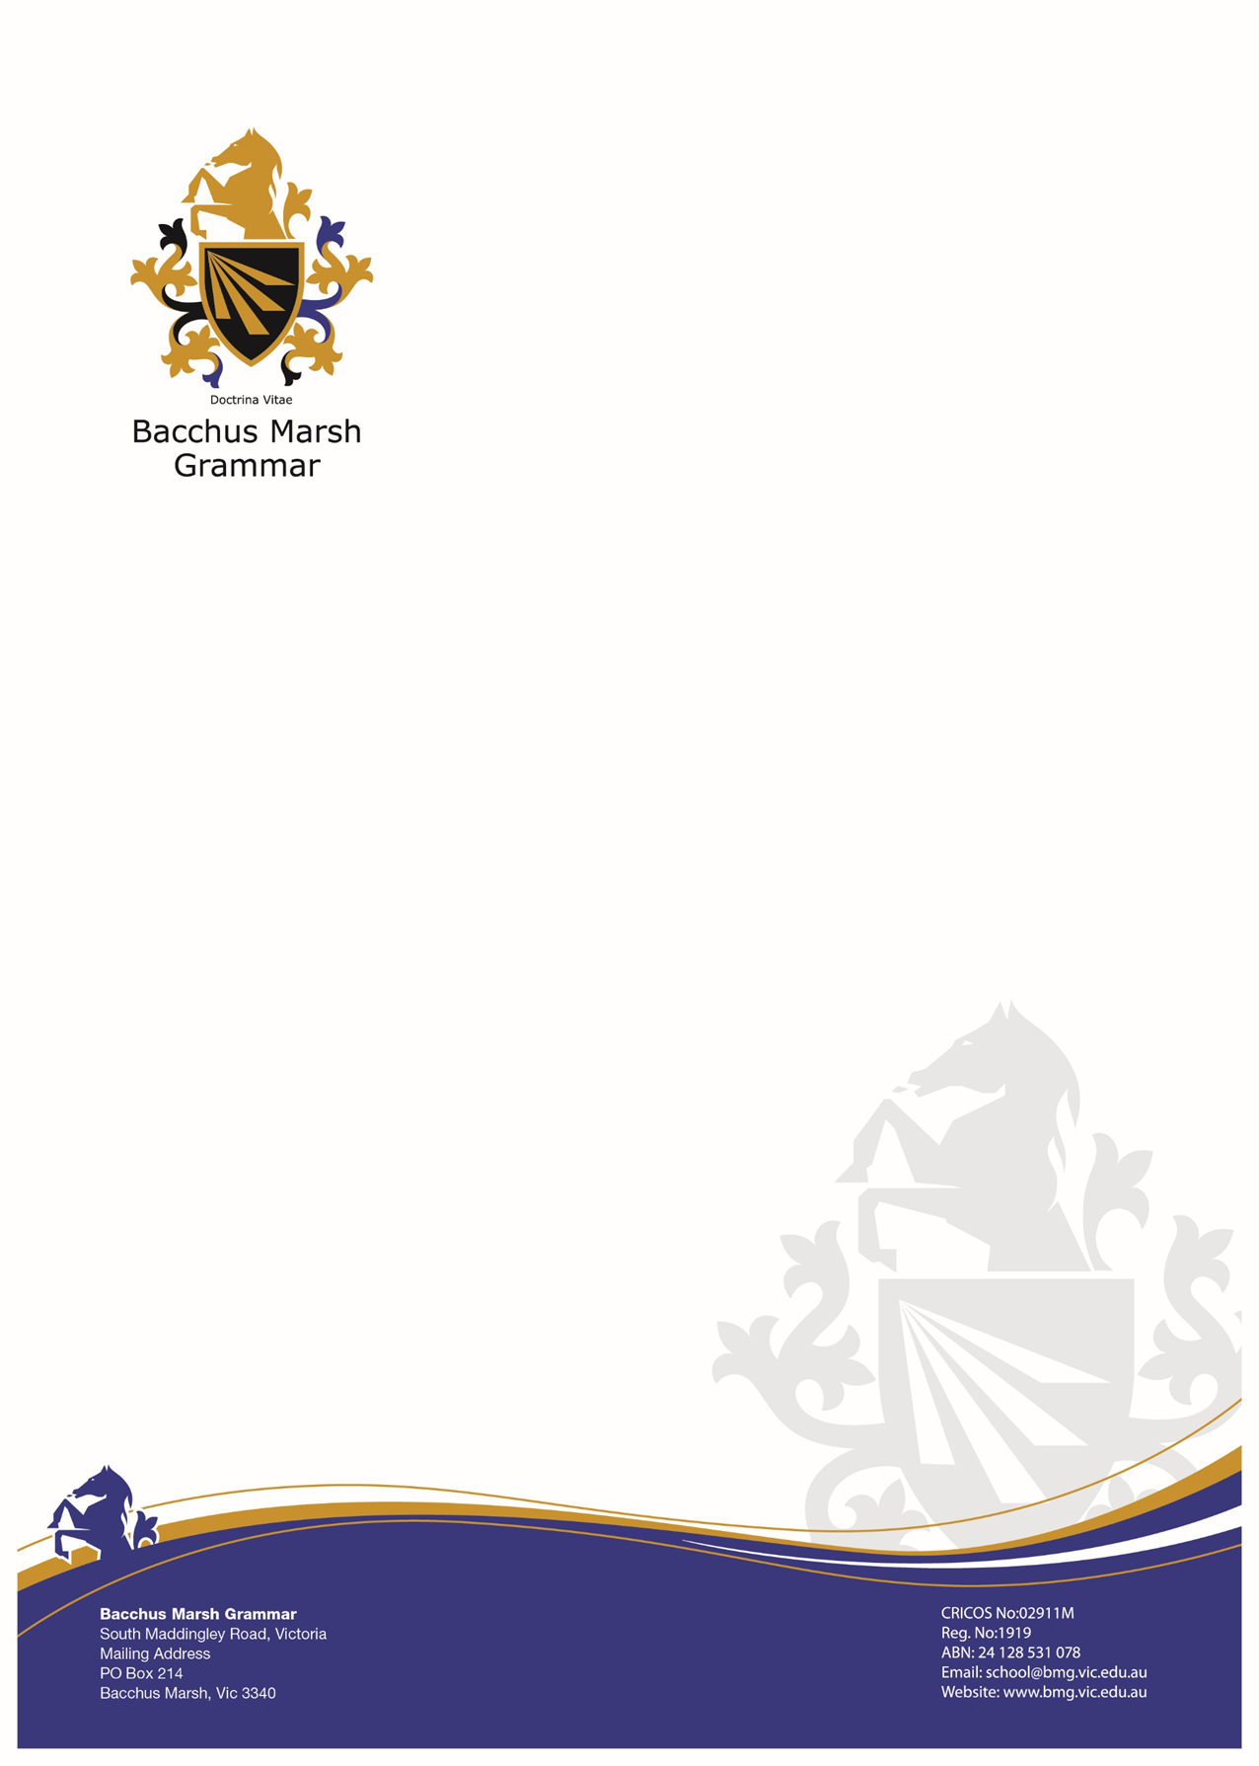
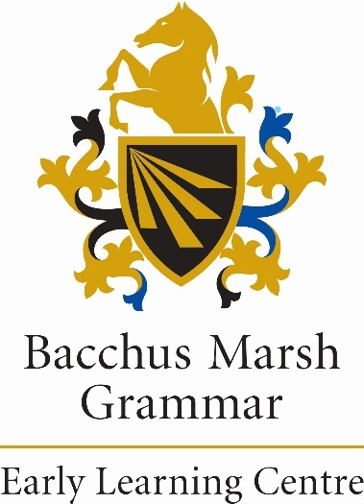

Position Description
Kindergarten Program Early Childhood Co-Educator
BMG EBA Award 2023

POSITION DESCRIPTION

POSITION: Kindergarten program Early Childhood Co-Educator

ORGANISATIONAL UNIT: Bacchus Marsh Grammar

POSITION STATUS: As per contracted hours

CLASSIFICATION: Bacchus Marsh Grammar EBA

POSITION OVERVIEW:

Work cooperatively as a member of a team, and assist with the provision of a high quality educational program for the children based upon the principals and practices of both the National and Victorian Early Years Learning Frameworks.

Operate in a professional manner at all times and ensure that the service meets the requirements of the Education and Care Services National Regulations, the Education and Care Services National Law Act and the policy and procedures of Bacchus Marsh Grammar and Bacchus Marsh Grammar Early Learning Centre

Uphold the safety, rights and wellbeing of all children and promote a culture of child safety with a zero-tolerance approach to child maltreatment, abuse and neglect

OUR MISSION
Bacchus Marsh Grammar seeks to meet the desire of the community for an independent education that is comprehensive, challenging and enriching. The school aims to be a safe and caring environment which, through its programs, encourages students to be confident, self-aware, able to contribute to their personal growth and who are willing to be active and positive members of society. With our students, we wish to encourage a strong sense of service, which sees that a commitment to inclusion and a willingness to assist others is a vital component of developing a positive character and a strong society. The school seeks to develop a culture of achievement, which encourages staff and students to strive toward achieving their personal best. In short, we offer and “Education for Life”.

OUR VISION
To develop as a Co-educational, Ecumenical day school that provides a quality education for students in the Outer Western area of Melbourne, which has a strong emphasis on individual care, personal development and pastoral care. In particular, to be a school that:
- Knows the individual and is able to work with their particular strengths and weakness.
- Actively encourages students to be involved in a diverse range of curricular and co-curricular activities.
- Fosters a sense of openness, community responsibility and tolerance within students.
- Prepares students for the world after school through a conscious emphasis on “Education for Life”.
- Through its programs and teaching, supports and promotes, the principles and practice of Australian democracy, including a commitment to:
- Elected Government
- The role of law
- Equal rights before the law
- Freedom of religion
- Freedom of speech and association
- The values of openness and tolerance

Philosophy – Appendix 1
Commitment to Child Safety – Appendix 2

KEY DUTIES & TASKS
- General Responsibilities

- Work under the direction of the Lead Early childhood teacher in accordance with the requirements the Education and Care Services National Law and Regulations.
- Undertake all responsibilities associated with being the person in day-today charge when required, in accordance with the Regulations and the Act.
- Be aware of, and assist with, implementing the service’s policies and procedures.
- Assist with the preparation, general cleanliness and safety of the service and the packing away of equipment and materials as directed by the teacher.
- Work directly with the children in the kindergarten program with mentoring from Lead Early Childhood Teacher (Kindergarten teacher)
- Ensure all ratios are met at all times and all children are correctly signed in and out throughout the day.
- All communication from families/parents are communicated in a timely and professional manner to lead Early childhood teacher (Kindergarten teacher), Educational leader and director of early learning.
- Follow the National Quality Standards (NQS), the service Self Assessment and Quality Improvement Planning (QIP) process.
- Other duties as directed.
- Attend all service meetings, as per the educator and management policy.

Children

- Assist with the program and daily routines, as directed by the teacher.
- Contribute to the planning cycle, by documenting spontaneous learning experiences and modifications.
- Assist the Lead Early Childhood Teacher (Kindergarten Teacher) in the provision of a healthy, safe and welcoming environment for the children and families attending the service.
- Assist in working with individual and small groups of children.
- Attend to the physical, social and emotional needs of the children as required.
- Ensure that any child or group of children are adequately supervised, and that every reasonable precaution is taken to protect them from any hazard.
- Inform the Lead Early Childhood Teacher (Kindergarten Teacher), or Educational Leader and Director of Early Learning Services, if the requirements of the Regulations are not being met.
- Take written observations of children as required, under the teacher’s direction.
- Assist with the preparation and cleaning-up of activities under the supervision of the teacher
- The employee will determine the non-contact time undertaken

Parents
- Assist in developing good relationships and effective communication with families.
- Ensure parents consult with the Lead Early Childhood Teacher (Kindergarten Teacher) on issues of children’s development and program.
- Maintain confidentiality on all issues relating to children and families and comply with the service’s privacy policy.

Administration
- Participate in annual staff review/performance development review process.
- Propose relevant professional development and training programs, and participate in professional development activities, as approved or requested by Lead Early Childhood Teacher, Educational Leader or Director of Early Learning.
- Record any incident, accident, illness or medication given;
- Ensure all incident, accident, illness or medication forms are signed by parent daily.
- Report to the Director of Early Learning. any incident, accident or medication given; and
- Notify the Director of Early Learning.of any toys or equipment in need of repair.

Quality and Standards
- OH&S – identification, mitigation of potential risks;
- Risk Management – identity, mitigation of potential risks; and
- Understanding of and full compliance of all relevant regulatory framework.

- Managing Self & Professional Skills
- Adhere to and comply with Child Safe Standards regulations and Child Safe Code of Conduct.
- Manage own behaviour in accordance with the Staff Code of Conduct.
- Adhere to and cooperate with all OHS policies and procedures and relevant legislation.
- Comply with legal, regulatory, ethical, environmental, and social responsibilities and requirements.
- Act professionally towards resolution of any conflict that may arise.
- Ability to ensure confidentiality of information

Working with People
  - Contribute as a proactive and effective member of a vibrant professional services team, whose activities integrate and promote the organisation’s values.
  - Participate in meetings in an active & constructive manner.
  - not tolerate racism, adopt measures to identify and confront racism, and address instances of racism with appropriate consequences

- Other duties
- The incumbent can expect to be allocated duties, not specifically mentioned in this document, but within the capacity, qualifications and experience normally expected from persons occupying positions at this classification.

ORGANISATIONAL RELATIONSHIPS
Reporting directly to: Director of Early Childhood Services, Educational leader and Lead Early Childhood Teacher.

Direct reports to this position: n/a

- Internal Relationships: This position may have relationships with staff from a range of different departments within Bacchus Marsh Grammar.

- External Relationships: This position will actively liaise and network with a number of external service providers, organisations and stakeholders within the community, with the view of providing the most appropriate and effective services and supports to the people they support.

CHILD SAFE
- Please see attached policy
- The Child Safe Standards aim to protect children and young people by requiring organisations to implement policies, procedures and processes to prevent and respond to abuse. They aim to keep children and young people safe, a key focus of organisations in Victoria.

All staff are required to complete a disclosure of connection with children and families if you have any affiliation with BMG students outside of the ELC.
We are committed to being a child safe, child friendly and child empowering organisation. In everything we do we seek to protect children. We listen and respond if harm or abuse occurs and remain open, honest, and transparent about any failings.
At Bacchus Marsh Grammar, Early Learning Centre, Woodlea, we comply with the National Child Safe Principles and the Victorian Child Safe Standards. The standards are a minimum set of requirements for organisations providing services to children in Victoria. This ensures that the safety of children is promoted, child abuse is prevented and allegations of child abuse are properly responded to.
There are 11 Child Safe Standards:
Standard 1: Organisations establish a culturally safe environment in which the diverse and unique identities and experiences of Aboriginal children and young people are respected and valued
Standard 2: Child safety and wellbeing is embedded in organisational leadership, governance and culture
Standard 3: Children and young people are empowered about their rights, participate in decisions affecting them and are taken seriously
Standard 4: Families and communities are informed, and involved in promoting child safety and wellbeing
Standard 5: Equity is upheld and diverse needs are respected in policy and practice
Standard 6: People working with children and young people are suitable and supported to reflect child safety and wellbeing values in practice
Standard 7: Processes for complaints and concerns are child focused
Standard 8: Staff and volunteers are equipped with the knowledge, skills and awareness to keep children and young people safe through ongoing education and training
Standard 9: Physical and online environments promote safety and wellbeing while minimising the opportunity for children and young people to be harmed
Standard 10: Implementation of the Child Safe Standards is regularly reviewed and improved
Standard 11: Policies and procedures document how the organisation is safe for children and young people.
Further information on the child safety standards can be found at the Commission of Children and Young People.
There is zero tolerance for any form of child abuse or maltreatment within the organisation. Any suspected abuse or maltreatment must be reported both internally and to external authorities including Child Protection and Child first.
If you have concerns that a child is at risk of significant harm as a result of abuse or neglect, please contact Child Protection.

PRIVACY
- Please see attached Policy

KEY SELECTION CRITERIA

Skills, Knowledge and Experience
Essential Criteria
- Knowledge and experience in the assistance of delivery of a quality early childhood program.
- Demonstrated knowledge and understanding of children’s development and children’s family needs in a multicultural setting from diverse cultural, socioeconomic and religious backgrounds;
- Demonstrated knowledge and understanding in the application of Children’s Service Centre Regulations including Mandatory Reporting requirements;
- Ability to be a valuable member of the early learning services team and contribute to the teams ongoing development; and

Qualifications
Essential Criteria
- Diploma of Children’s services
- First Aid Certificate; HLTAID012
- Asthma & Anaphylaxis Certificate;
- Current working with children check.
- National Police Check
- Protecting Children: Mandatory Reporting and Other Obligations for Early Childhood certificate (current)

AUTHORISATION

Approved: Date: ________________
Debra Ogston
Principal

I have read and agree to abide by the requirements of this position description.

Print Name: ____________________________________________________________

Signed: ________________________________ Date: _________________________

Appendix 1

Bacchus Marsh Grammar Early Learning Centre

Child Safety Commitment Statement

Bacchus Marsh Grammar Early Learning Centre is committed to the safety and well-being of all children and young people. We understand our responsibilities and statutory duty of care to comply with both the Victorian Child Safe Standards and the Reportable Conduct Scheme to build our capacity as an organisation to prevent and respond to allegations of child abuse.

Our Service is committed to implementing and abiding by our Child Safe Policy based on Child Safe Standards in Victoria (2022), accentuating our zero tolerance for child abuse and raising awareness about the importance of child safety in our Service and the community. We are dedicated to protecting children from abuse and neglect and, promoting a child-safe environment, maintaining children’s well-being.

We adhere to our comprehensive Child Protection Policy, following our mandatory reporting responsibilities to protect children from physical, sexual, emotional, and psychological abuse and neglect.
We are dedicated to promoting cultural safety for Aboriginal children, cultural safety for children from culturally and/or linguistically diverse backgrounds and providing a safe environment for children with a disability. We are committed to ongoing professional development for employees to maintain their ability to distinguish and respond to situations of abuse and neglect, ensuring employees are responsive to their responsibilities in keeping children safe.

We work in collaboration with the United Nations Convention on the Rights of the Child and have confidence in educating children about their right to be safe. At Bacchus Marsh Grammar Early Learning Centre, we know that children learn best when they feel safe and are safe. We believe in teaching children what to do if they feel unsafe and encouraging them to express their views and thoughts on matters that directly affect them. As educators, we listen to and empower children to act on any concerns they or others may raise, which is reflected in our policies and procedures for keeping children safe.

Appendix 2
Centre Philosophy

At Bacchus Marsh Grammar Early Learning Centre our school values guide a respectful, inclusive, and empowering learning community. We are committed to fostering a calm, inviting, and stimulating environment where every child feels safe, valued, and capable.
We respectfully acknowledge the Wurundjeri and Wathaurong Peoples, the Traditional Custodians of the land on which we learn and play. We recognise that Indigenous knowledge systems, stories, and cultural practices are vital in shaping our programs and are woven meaningfully throughout our curriculum and environment. This perspective is not separate but embedded into our daily learning, community engagement, and understanding of place.
Curriculum/Framework
Our curriculum is guided by the Early Years Learning Framework and reflects a deep commitment to children’s rights, agency, and voice. We believe children are competent, capable decision-makers who are active participants in their learning journeys. Their curiosity, creativity, and contributions shape our curriculum, which is built around open-ended, meaningful experiences.
Through an integrated and intentional approach, together with the knowledge, and goals shared by families we support each child’s development across all learning domains including early literacy, numeracy, STEAM, sustainable practices, cultural competence, and physical and creative expression. This will be achieved through centre operations, high expectations, intentional teaching, inquiry-based project work, questioning, discussions, and open-ended authentic experiences where children become curious and inquisitive learners. We value and embed sustainable practices and environmental awareness as an everyday responsibility and opportunity for children to become leaders in creating a better world.
Our diverse teaching team draws on a range of evidence-based theories and research, supporting flexible and responsive pedagogy. Learning is not bound by routines it is enhanced by them. Rituals and responsive routines are purposefully designed to build trust, create belonging, and reflect each child and their family.
Wellbeing, Child Safety, and Rights
Educators intentionally nurture the social and emotional development of every child, supporting independence, resilience, and a strong sense of identity and belonging. The children will be exposed to a creative environment to build skills that empower them to confidently solve problems independently and collaboratively. We are a child-safe organisation with zero tolerance for child abuse. We will promote our statement of commitment to child safety and wellbeing and model a child safe culture at all levels in our service. We actively implement the 11 Child Safe Standards to promote a culture of safety, respect, and inclusion. Every child has the right to feel safe, to be heard, and to express themselves.
Diverse Learning Environment
Our diverse learning environments are aesthetically appealing, inviting, and designed to ensure that children are engaged and challenged. Individual and group learning opportunities are supported through a high-quality learning environment where children become confident learners who can direct their learning and take considered risks. This will be achieved through exposure to various experiences, opportunities and community involvement.
Our diverse learning environments extend across spaces that inspire curiosity, connection, and discovery. They are thoughtfully designed to be aesthetically appealing, inviting, and rich in opportunities that engage and challenge children. Whether exploring within the centre, in natural outdoor settings, or out in the wider community, children are supported to direct their own learning, collaborate with others, and take considered risks. Through these varied experiences and opportunities, children grow as confident, capable learners with a strong sense of belonging.
Cultural Competence and Inclusion
We are committed to ensuring that all voices are heard, valued, and reflected in our practices, creating a culturally safe and inclusive environment. Our curriculum reflects and respects the diverse cultures, languages, and traditions of our children, families, educators and community. Events and celebrations are viewed as an opportunity to foster genuine understanding, learning and connection.
Professional Growth and Reflection
Educators’ wellbeing is promoted through a supportive work environment and a cohesive team culture whilst encouraging staff to challenge themselves as professionals. As a professional learning community, we are committed to ongoing critical reflection and professional growth. Educators regularly reflect on their values, biases, and practices to ensure continuous improvement. Through collaborative dialogue, mentoring, and inquiry, we strive for excellence in early childhood education.

