

POSITION DESCRIPTION

CORPORATION OF THE CITY OF UNLEY

- JOB IDENTIFICATION:

Title of Position: DEVELOPMENT ADMINISTRATION OFFICER
Business Unit: CITY DEVELOPMENT
Reports to: TEAM LEADER PLANNING
Classification: MOA LEVEL 3

- POSITION OBJECTIVES:

To provide administrative support to the Development Services Team and high level customer service to the community.

- KEY RESPONSIBILITIES:

While working under general supervision from the Team Leader Planning and exercising a degree of autonomy:
    - Prepare the Council Assessment Panel agenda and minutes along with other administrative tasks related to the Council Assessment Panel functions.
    - Prepare the Building Fire Safety Committee agenda and minutes along with other administrative tasks related to the Building Fire Safety Committee functions.
    - Coordinate the Essential Safety Procedures system for commercial buildings including the regular updating of the register.
    - Provide general administrative support to the Planning and Building teams as required.
    - Provide general administrative support requiring a degree of judgement, initiative and confidentiality to the Manager Development and Regulatory as required.
    - Administration of the Section 7 searches and Liquor License applications.
    - Maintain the Land Management Agreement and other registers as required.
Promptly forward enquiries and other customer matters that are outside of the Officers expertise to the appropriate Officer.
    - Act in the role of the Customer Liaison Officer in a backup capacity to provide support in the following tasks:
    - reliable and consistent advice in relation to development application submissions and respond to the general development related enquiries;
    - Records management of development assessment related documents in accordance with established practices; and
    - Administration of the Conservation Grants process under the guidance of the Manager Development and Regulatory.
    - Demonstrate the City of Unley values and leadership attributes when working with others and the community.
Position Description: Development Officer
DOC SET ID: 3061904
Page 1 of 4 Updated: July 2025
    - Comply with the City of Unley’s Records Management Policy, procedures and practices for all records created and received.
    - Undertake other duties associated with the position as required.

Staff must comply with WHS and Return to Work SA legislation requirements and relevant WHS policies, procedures and safe work practices implemented by the City of Unley.

Key WHS Responsibilities:

    - Actively support and contribute to the City of Unley’s effective safety culture.
    - Identify and report health and safety hazards, accidents, incidents, injuries and property damage within the workplace.
    - Taking reasonable care to ensure their own safety and not placing others at risk, including appropriate use of equipment and PPE.
    - Complying with the requirements of the City of Unley’s WHS management system.
    - Attending WHS training and following instructions and advice provided.

SAFE ENVIRONMENT:

    - Comply with the City of Unley Safe Environment policy and all relevant policies and procedures.
    - Notify the Department of Human Services if, on reasonable grounds, you suspect that a child has been or is being abused or neglected if the suspicion is formed in the course of your work while carrying out official duties.
    - Notify the Department of Human Services if, on reasonable grounds, you suspect that an aged and/or vulnerable person has been or is being abused or neglected if the suspicion is formed in the course of your work while carrying out official duties.
    - Seek advice and support from your Team Leader, Manager or the People & Culture team if a notification is required.
    - Advise your Team Leader, Manager or the People & Culture team if there is a change in your criminal history status and undertake a Department of Human Services Screening every three or five years (time frame is related to specific clearance type), unless more regular screening is required for legislative purposes.


EQUAL OPPORTUNITY EMPLOYMENT

Contribute to the promotion and adherence of the employee conduct standards and in particular Equal Opportunity by adhering to the provisions of relevant legislative requirements.
Actively support and contribute to the City of Unley’s organisational values.

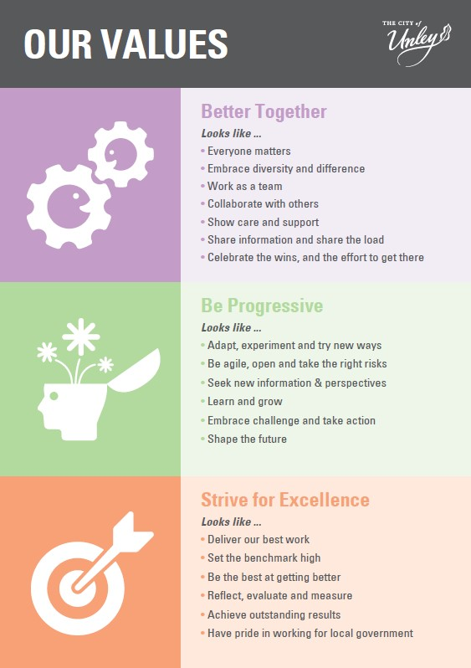

- PERFORMANCE AND SKILL REQUIREMENTS:
a) Qualifications/Experience
Essential
  - Relevant qualifications and/or extensive experience relevant to the position.

NOTE: Copies of the above listed qualifications/licences/certificates are required as evidence on appointment.

Desirable
  - Experience liaising with customers and resolving queries.
  - A detailed working knowledge of the Planning, Development and • Infrastructure Act 2016, Local Government Act 1999 as well as other
  - relevant legislation, policies and procedures.

c) Skills
Essential
An ability to actively listen, provide attention to detail and explain complex issues with customers.
  - Exceptional phone manner and ability to communicate with all types of personalities.
  - Demonstrated experience in building good relationships with customers, offering unique and innovative solutions and partnering with them to provide the best experience.
  - Proficiency in the operation of Council’s systems including Windows-based software applications (Word, Excel, PowerPoint) and internet technologies.
  - An ability to prepare agendas and to take accurate minutes of meetings.
  - Superior written and verbal communication skills for clarity, accuracy and context.
  - Effective organisation and time management skills.
  - Ability to operate effectively in a team, contributing positively to team operations and working relationships

By signing this position description, the employee and the employee’s manager agrees that it is an accurate reflection of the responsibilities and requirements of the position:

Incumbent: ........................................................ Date: .............................

Manager: ........................................................ Date: ..............................

