

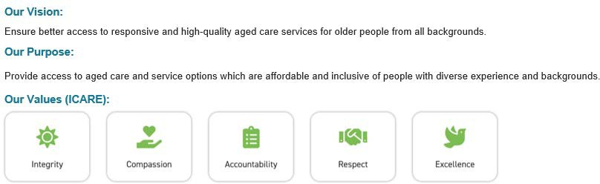
Position Description

Position Title: | Food Services Assistant (FSA) | Position Reports To: | Head Chef/Cook
Positions Reporting to this Position: | Nil

Position Purpose: | The Food Services Assistant is responsible for providing high quality hospitality service and catering support to the residents. Key to the role is assisting with meal preparation and presentation, delivery and serving of resident meals, as well as associated cleaning duties of kitchens, dining rooms and other food areas.
Qualifications: | Food Safety and Food Handling Certificate III or greater
Skills: | - Knowledge of Food Safety and Government Regulations  - Knowledge of OH&S and infection control specific to catering  - Effective and positive communication skills  - Demonstrates excellence in customer service at all times
Experience: | Experience in a kitchen environment and food services (preferably Residential Aged Care)
Resident Dignity and Choice  (Aged Care Quality Standard 1) | - Treat all residents with dignity and respect, valuing their identity, culture and diversity.  - Support residents to exercise choice and independence: to make decisions about their own care, the way care services are delivered and how family and others are involved in their care.  - Ensure all resident information is kept confidential, privacy is respected and information provided to the resident is clear and easy to understand so residents may exercise choice.

Date Issued | Chapter | Section/Document | Revision Number | Page Number

Resident Dignity and Choice cont… | - Assist with the planning, preparation and delivery of a high quality food and beverage service that respects individual choice and meets dietary, nutritional and cultural requirements.
Ongoing Assessment and Planning | - Ensure resident care services delivery is based on the current needs, goals and preferences of residents as identified in partnership with the resident/participant and others the resident wishes to involve in the planning process.  - Ensure assessment and planning, including consideration of risks to resident health and well-being, informs the delivery of safe and effective care and services.  - Assist with and be aware of documentation concerning dietary requirements, cultural preferences and likes and dislikes of residents.  - Complete and maintain accurate documentation required according to food safety program and Doutta Galla policies and procedures.  - Undertake audits as directed - for internal purposes and external bodies (such as Councils).
Personal and Clinical Care | - Ensure interactions with residents/participant and their representatives are kind, caring and respectful of each individual’s identity, culture and diversity.  - Effectively manage high-impact/high-prevalence risks associated with the care of each resident, including the delivery and serving of food and drinks to residents.  - Ensure needs, goals and preferences of residents nearing the end of life are recognised and addressed, their comfort maximised and dignity preserved.
Support For Daily Living | - Ensure daily living support meets individual resident/participant needs, goals and preferences and optimises resident/participant independence and health as well as emotional, spiritual, psychological well-being and quality of life.  - Provide daily living services and support that facilitate social and personal relationships, meet individual resident/participant interests and enables broader participation.  - Cater for special occasions such as birthdays or cultural and religious occasions.  - Report any changes in resident dietary habits.
OH&S | - Ensure the maintenance of a safe working environment that meets regulatory requirements and undertake all duties in a manner that demonstrates, at all times, due regard for the wellbeing and safety of self, colleagues and

Date Issued | Chapter | Section/Document | Revision Number | Page Number

OH&S cont… | residents.  - Adhere to Occupational Health and Safety Act and associated policies and procedures.  - Respond appropriately to situations of risk or potential risk to residents, staff and public.  - Monitor the safety of equipment and ensure equipment is maintained and used in a safe manner in line with manufacturer’s instructions and organisational guidelines, and report any breakdown or requirements to the Registered Nurse In-Charge, CCC or Facility Manager/Residential Services Manager.  - Ensure meals are prepared, served and/or stored at appropriate temperatures in accordance with food safety legislation and the facility Food Safety Program.  - Actively participate in training and education sessions regarding occupational health and safety.  - Understand emergency code management, fire and evacuation procedures and implement if required.  - Report immediately all accidents / incidents in accordance with organisational guidelines and where necessary document in accordance with organisational guidelines.
Feedback and Complaints | - Provide support to residents/participant and their families regarding any queries, comments, suggestions and/or concerns and ensure they are managed promptly, effectively and efficiently or referred to an appropriate level of responsibility.  - Comply with all Privacy Legislation requirements and Doutta Galla confidentiality statements when communicating information pertaining to residents, staff and the operations of any Doutta Galla facilities.  - Facilitate awareness of and access to advocates, language services and other methods of raising and resolving complaints in accordance with Doutta Galla policies and procedures and within scope of role.

Date Issued | Chapter | Section/Document | Revision Number | Page Number

Name:
Signature:
Date:

Acknowledgement | - I have read this position description and agree to undertake the duties and responsibilities as listed above.  - I understand I am responsible for ensuring I undertake my duties in compliance with the Aged Care Quality Standards and any relevant Aged Care legislation.  - I understand I am responsible for ensuring I undertake my duties in compliance with the NDIS Practice Standards where required.  - I understand this position description is subject to review and amendment at any time, as appropriate and approved by HR and/or Doutta Galla management.  - I also acknowledge that I may be required to undertake additional duties and responsibilities from time to time that are not detailed above.  - I have read and understood the Doutta Galla Code of Conduct.

Date Issued | Chapter | Section/Document | Revision Number | Page Number

