

POSITION DESCRIPTION

CORPORATION OF THE CITY OF UNLEY

- JOB IDENTIFICATION:

Title of Position: TEAM MEMBER ARBORICULTURE Business Unit: CITY DEVELOPMENT
Reports to: TEAM LEADER ARBORICULTURE
Classification: TEAM MEMBER

- POSITION OBJECTIVES:
  - Support the Team Leader to ensure the City of Unley’s arboriculture operations are delivered in line with Council’s endorsed Tree Policy and Strategy service levels.
  - Ensure the completion of duties associated with Council’s Management of its arboricultural assets.
  - Undertake arboricultural activities and support the Team Leader to ensure work plans are delivered efficiently, safely and are consistent with work methods and procedures.
- KEY RESPONSIBILITIES:
  - Undertake arboricultural maintenance activities including formative tree pruning, mature and veteran tree pruning, tree planting, tree removal, water truck operation and general arboricultural tasks.
  - Utilise plant and equipment including elevated platform vehicles, woodchippers, and chainsaws (petrol, hydraulic, pneumatic).
  - Participate in the development and delivery of short and long-term planning.
  - Collect and record performance-measuring data as required.
  - Ensure Council’s record keeping requirements are met through the utilisation of mobility devices.
  - Ensure operations comply with Council’s policies, procedures and guidelines.
  - Ensure the establishment of a safe work environment with the use of temporary signage through effective Work Zone Traffic Management.
  - Support the implementation and review of procedures and processes to improve efficiency.
  - Assist in the implementation of environmental, and risk and safety improvement initiatives.
  - Assist in ensuring tasks performed adhere to the environmental principles and guidelines of the City of Unley.
  - Liaise with residents and assist with the resolution of customer requests and complaints.
  - Demonstrate commitment, compliance, and performance in relation to Council’s Values and expected behaviours, and Enterprise Bargaining Agreement.
  - Assist the Team Leader Arboriculture and undertake other duties related to the position as required
Staff must comply with WHS and Return to Work SA legislation requirements and relevant WHS policies, procedures and safe work practices implemented by the City of Unley.
Key WHS Responsibilities:
- Actively support and contribute to the City of Unley’s effective safety culture.
- Identify and report health and safety hazards, accidents, incidents, injuries and property damage within the workplace.
- Taking reasonable care to ensure their own safety and not placing others at risk, including appropriate use of equipment and PPE.
- Complying with the requirements of the City of Unley’s WHS management system.
- Attending WHS training and following instructions and advice provided.

EQUAL OPPORTUNITY EMPLOYMENT
Contribute to the promotion and adherence of the employee conduct standards and in particular Equal Opportunity by adhering to the provisions of relevant legislative requirements.
Actively support and contribute to the City of Unley’s organisational values.
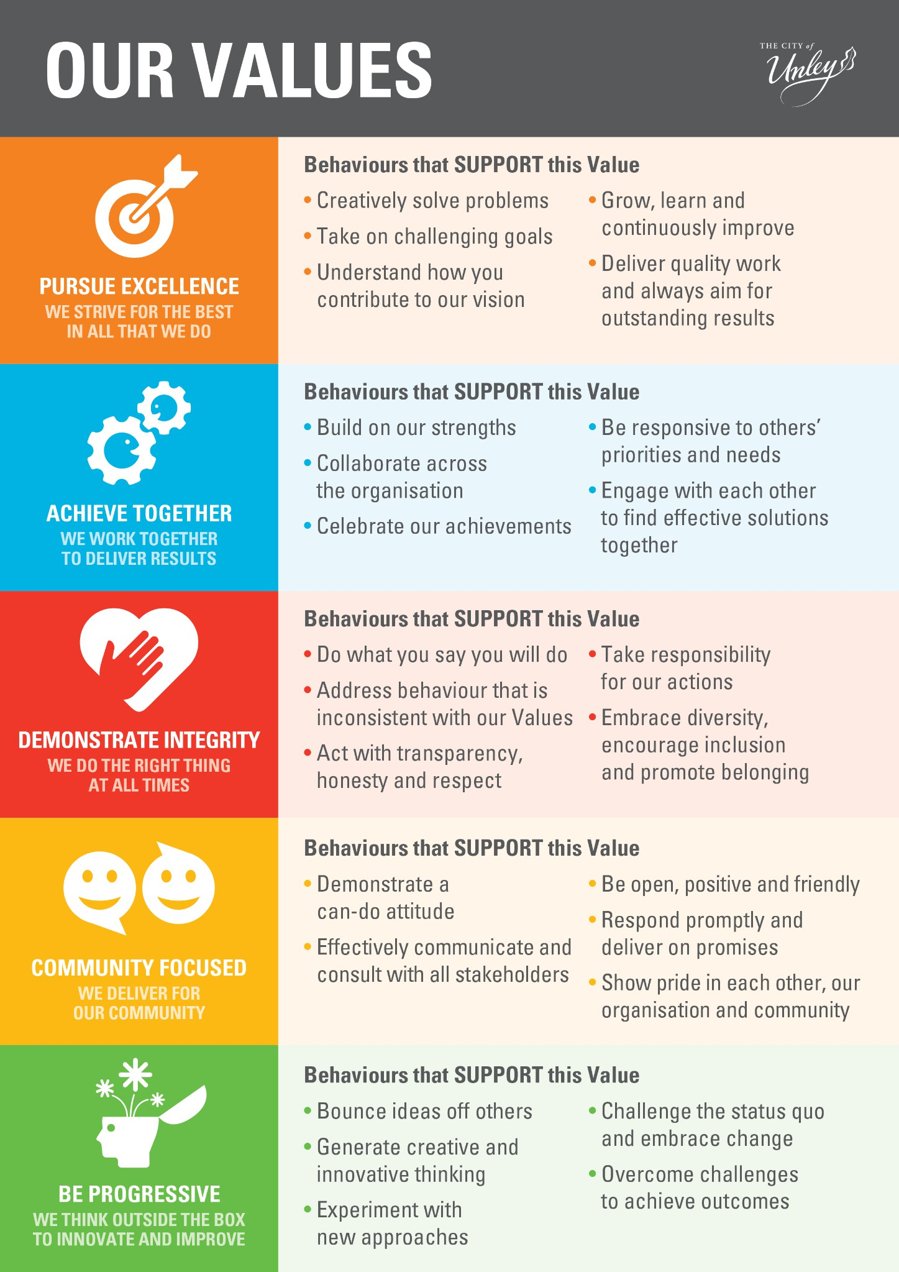
- PERFORMANCE AND SKILL REQUIREMENTS:
- Qualifications/Experience Essential
  - Relevant qualifications and/or extensive experience in arboriculture relevant to the position.
  - Driver’s Licence
  - MR Licence (or higher)
  - Experience working in a team environment.
  - High Risk Work License (EWP – Elevated Work Platform).
  - Work Zone Traffic Management (WZTM) accreditation.

NOTE: Copies of the above listed qualifications/licences/certificates are required as evidence on appointment.

Desirable
  - Experience liaising with customers and assisting with the resolution of concerns.

- Knowledge Essential
  - Knowledge of safety practices and procedures in relation to work methods, plant, equipment and tools used to perform duties.

Desirable
  - Knowledge of the Work Health and Safety Act 2012 (SA), and Work Health and Safety Regulations 2012 (SA).
  - Knowledge of the principles of customer service excellence.
  - Commitment to ongoing professional development and continuous learning.

- Skills
Essential
  - Proficiency in the use of Microsoft Office and the ability to use smart tablets in a working environment.
  - Willingness and ability to work as an effective team member and contribute towards team goals.
  - Ability to relate to a diverse work environment and to proactively resolve concerns constructively.
  - Able to adopt innovative approaches, new ideas and opportunities.
Desirable
  - Sound oral and written communication skills.
  - Skills in managing time and priorities.

By signing this position description, the employee and the employee’s manager agrees that it is an accurate reflection of the responsibilities and requirements of the position:

Incumbent: ........................................................ Date: .............................

Manager: ........................................................ Date: ..............................

