1. JOB IDENTIFICATION:

Title of Position: TEAM MEMBER CIVIL & RESPONSE
Business Unit: CITY DEVELOPMENT
Reports to: TEAM LEADER CIVIL & RESPONSE
Classification: TEAM MEMBER LEVEL 5

2. POSITION OBJECTIVES:
- Support the Team Leader of Response and Signage to ensure scheduled maintenance and work plans are delivered efficiently, timely, safely and are consistent with work methods, procedures and specified standards.
- Contribute to the maintenance of Council owned assets by undertaking a range of general maintenance, repairs and cleansing activities to buildings, facilities, parks, roads, footpaths, street furniture, signage and other public amenities.
- Assist in the completion of customer requests in line with Council’s Customer Service Charter.
Respond to emergency situations as required with regard to flooding, storm damage or any other identified emergency.

- KEY RESPONSIBILITIES:

- Utilise plant and equipment including backhoe, excavator, loader, sweeper (MR), leaf blowers and chainsaws (petrol, hydraulic, pneumatic) to complete daily work plans in accordance with scheduled programs.
- Undertake construction and maintenance activities including:
  - Paving repairs, concrete works (kerb and water table) road repairs and drainage maintenance;
  - Maintaining, replacing and installing street signs and traffic management data collection devices in the Council area as part of a defined program;
  - Footpath Sweeper operation cleaning of paths, bike paths, carparks etc.
  - Street and drainage cleaning, graffiti removal;
  - Street sweeping; and
  - Responding to emergency situations as needed.
- Internal and external maintenance or repair work to Council owned buildings and facilities as required.
- Collect and record performance-measuring data as required.
- Ensure Council’s record keeping requirements for the areas of responsibility are met through the utilisation of mobility devices.
- Actively assist to develop, implement and review procedures and processes to improve efficiency.
- Assist in the implementation of environmental, and risk and safety improvement initiatives.
- Liaise with residents and assist with the resolution of customer requests and complaints.
- Respond to customer requests in accordance with Council standards, ensuring reliable and timely completion and communication with customers.
- Assist the Team Leader Response and Signage and undertake other duties related to the position as required.
- Demonstrate commitment, compliance, and performance in relation to Council’s Values and expected behaviours and Enterprise Bargaining Agreement.
Required Work hours may vary between the stipulated ordinary daily hours 6:00am-7:00pm Monday to Friday depending upon the scheduled activity required to be completed.

Staff must comply with WHS and Return to Work SA legislation requirements and relevant WHS policies, procedures and safe work practices implemented by the City of Unley.

Key WHS Responsibilities:
- Actively support and contribute to the City of Unley’s effective safety culture.
- Identify and report health and safety hazards, accidents, incidents, injuries and property damage within the workplace.
- Taking reasonable care to ensure their own safety and not placing others at risk, including appropriate use of equipment and PPE.
- Complying with the requirements of the City of Unley’s WHS management system.
- Attending WHS training and following instructions and advice provided.

EQUAL OPPORTUNITY EMPLOYMENT
Contribute to the promotion and adherence of the employee conduct standards and in particular Equal Opportunity by adhering to the provisions of relevant legislative requirements.

Actively support and contribute to the City of Unley’s organisational values.

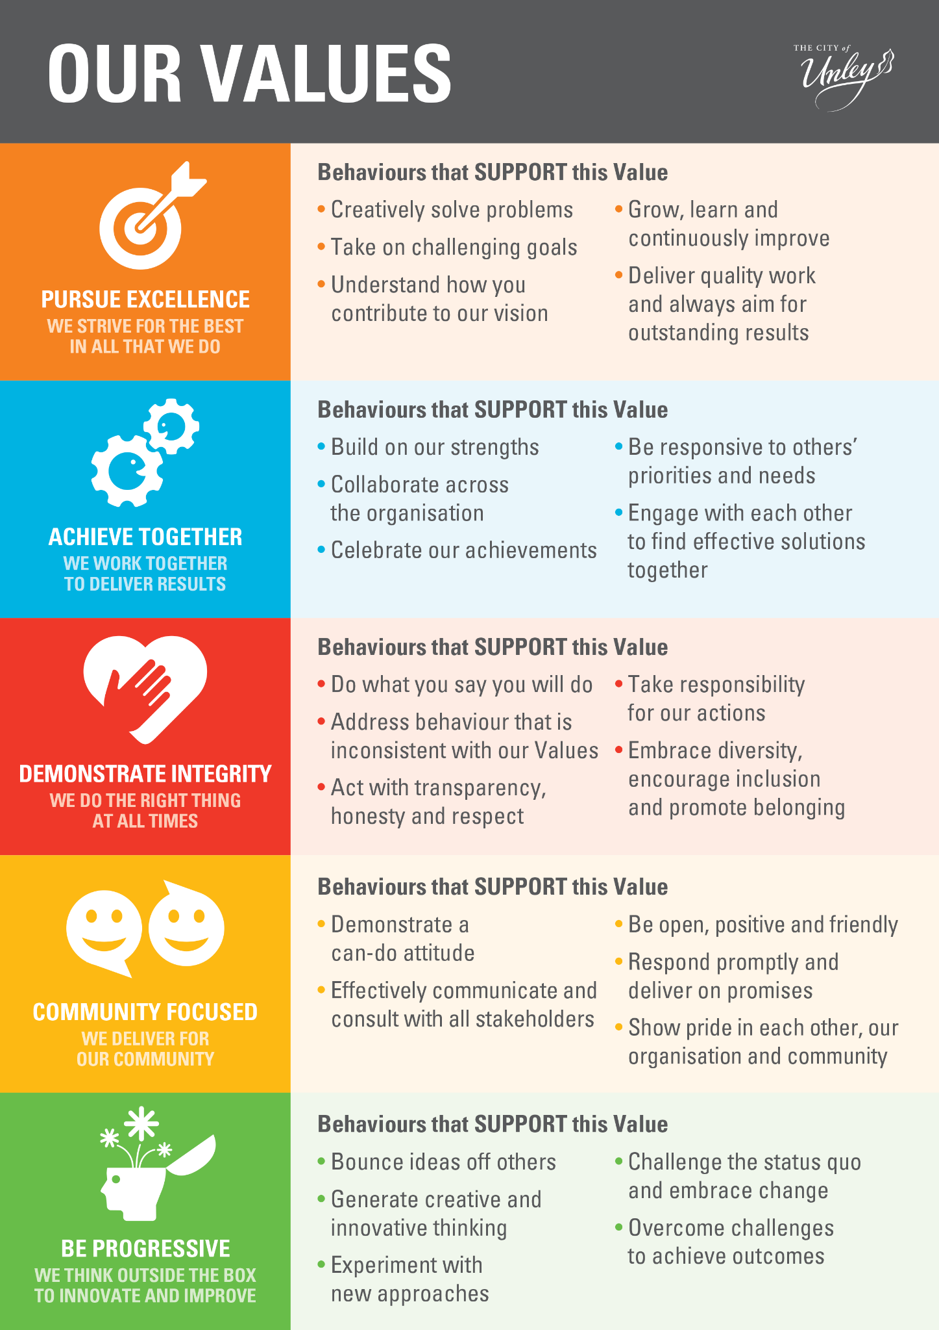

4. PERFORMANCE AND SKILL REQUIREMENTS:
a) Qualifications/Experience

Essential
- Relevant qualifications and/or extensive experience relevant to the position.
  - Experience in undertaking general internal and external maintenance work on buildings.
  - Experience in the operation of hand and power tools and other equipment associated with general maintenance work.
  - Experience in working in a team environment.
  - Driver’s Licence – ‘MR’ Class.
  - Work Zone Traffic Management (WZTM) Accreditation.

NOTE: Copies of the above listed qualifications/licences/certificates are required as evidence on appointment.

Desirable
  - Certificate III or relevant trade qualification
  - Experience liaising with customers and resolving queries.
  - Competent in the use of shift devices e.g. loader and backhoe, excavator.
  - Experience in maintaining, replacing and installing street signs and traffic management devices

b) Knowledge

Essential
  - Contemporary knowledge of civil, response, street cleansing, trades and signage operational processes and procedures
c) Skills

Essential
- Ability to contribute to problem solving and decision making.
- Organisation skills, including planning and prioritising maintenance work and job requirements.
- Willingness and ability to work as an effective team member and contribute towards team goals.
- Ability to relate to a diverse work environment and to proactively resolve concerns constructively.
- Able to adopt innovative approaches, new ideas and opportunities.
- Effective oral and written communication skills.
- Proficiency in the use of Microsoft Office and the ability to use smart tablets in a working environment.

By signing this position description the employee and the employee’s manager agrees that it is an accurate reflection of the responsibilities and requirements of the position:

Incumbent: ........................................................ Date: .............................

Manager: ........................................................ Date: ..............................

